

NATIONAL COLLEGE OF BUSINESS ADMINSTRATION & ECONOMICS (NCBAE)

Department OF Computer Science

**Project Report**

Submission Date:

SUBMITTED TO:

SECTION:

SUBJECT: Database Structure (Lab)

TOPIC: Restaurant Management System

|  |  |
| --- | --- |
|  |  |
|  |  |

Table of Contents

Restaurant Management System 6

1. Introduction: 6

1.1. Features: 6

2. Advantages and Disadvantages: 8

2.1. Advantages of Restaurant Management System: 8

2.2. Disadvantages of Restaurant Management System: 8

2.2. Need of Restaurant Management System: 9

3. Making of the Database Management System 10

3.1. Creating an ERD for the Database: 10

3.1.1 ERD for Tables: 12

3.1.1.1 ERD for Table Booking: 12

3.1.1.2 ERD for Table Customers: 12

3.1.1.3 ERD for Table Chefs: 13

3.1.1.4 ERD for Table Contact_Us: 14

3.1.1.5 ERD for Table Events: 15

3.1.1.6 ERD for Table Payments: 16

3.1.1.7 ERD for Table Testimonial: 17

3.1.1.8 ERD for Table Users: 18

3.1.2 ERD for Relationships: 19

3.1.2.1 ERD for Relationship between Customers and Contact_us: 19

3.1.2.2 ERD for Relationship between Customers and Testimonials: 19

3.1.2.3 ERD for Relationship between Customers and Booking: 19

3.1.2.4 ERD for Relationship between Customers and Events: 20

3.1.2.5 ERD for Relationship between customers and payment: 20

3.1.4. Use Case: 21

3.2. The Backend: 22

3.2.1. Creating the Database: 22

3.2.2. Creating Tables in the Database: 23

4. Tables: 29

Table Structure: 29

Uses and Function of the Table: 29

• Chefs: 30

Table Structure: 30

Uses and Function of the Table 31

• Contact us: 32

Table Structure: 32

Table Structure: 33

Uses and Function of the Table: 33

• Events: 34

Table Structure: 34

Uses and Function of the Table: 35

Table Structure: 36

Uses and Function of the Table: 36

• Testimonials: 37

Table Structure: 37

Uses and Function of the Table: 38

• Users: 39

Table Structures: 39

Uses and Function of the Table: 39

Security Note: 40

5. Use of Keys: 41

6. Detailed Breakdown 44

7. Benefits 45

9. Benefits of Foreign Key Constraints: 46

10. Summary of the Script 47

11. The Frontend: 48

• Define Requirements: 48

• Design UI/UX: 48

• Choose Technologies: 48

• Develop Front End: 48

• Connect to Database: 48

• Handle CRUD Operations: 48

• Error Handling: 49

• Testing: 49

• Iterate and Improve: 49

12. The Final Product: 50

• The User Interface: 50

13. Backend Connection with DB: 58

• Connect to the Database: 58

• Implement CRUD Operations: 58

• Security Measures: 58

• Testing: 58

• Error Handling and Logging: 58

References 60

**List of Figures**

Figure 1: ERD of Table Booking 12

Figure 2: ERD of Table Customers 13

Figure 3: ERD of Table Chefs 14

Figure 4: ERD of Table Contact_us 15

Figure 5: ERD of Table Events 16

Figure 6: ERD of Table payments 17

Figure 7: ERD of Table testimonial 18

Figure 8: ERD of Table users 18

Figure 9: Relationship between customers and contact_us 19

Figure 10: Relationship between customers and Testimonials 19

Figure 11: Relationship between customers and bookings 19

Figure 12: Relationship between customers and events 20

Figure 13: Relationship between customers and payments 20

Figure 14: ERD of Restaurant Management System 20

Figure 15: Use Case no 1 21

Figure 16: Use Case No 2 21

Figure 17: Creation of Database 23

Figure 18: Database name appeared on left sidebar. 23

Figure 19: Creation of Tables. 24

Figure 20: Table has been Created 24

Figure 21: Tables listed under sidebar. 25

Figure 22: Booking Table with data inserted in it. 25

Figure 23: All the Tables in the database. 28

Figure 24: Indexes for Booking table 41

Figure 25: Indexes for Chefs table 41

Figure 26: Indexes for Contact_us table 42

Figure 27: Indexes for Customers table 42

Figure 28: Indexes for Events table 42

Figure 29: Indexes for Payment table 43

Figure 30: Indexes for Testimonials table 43

Figure 31: Indexes for Users table 43

Figure 32: Constraints for tables 45

Figure 33: The User Interface 50

Figure 34: About Interface 51

Figure 35: Reasons to choose Hunger Hut 51

Figure 36: Menu Page 52

Figure 37: Starters in Menu 52

Figure 38: Main Course Section in menu 52

Figure 39: Specialty Section in menu 53

Figure 40: Hunger hut Specials 53

Figure 41: About our Chefs 53

Figure 42: Various Testimonials 54

Figure 43: Book a table Section 54

Figure 44: Contact_us Section 55

Figure 45: Login Page 55

Figure 46: Payment Table 56

Figure 47: Testimonial Table 56

Figure 48: Contact_us 56

Figure 49: Chefs Table 57

Figure 50: Booking Table 57

Figure 51: Database Connected 58

Figure 52: Plagiarism Check 59

# Restaurant Management System

## Introduction:

A restaurant management system (RMS) is a software solution that streamlines the planning, organization, and execution of restaurant operations. It serves as a centralized platform for tasks like menu planning, inventory management, table reservations, and customer service. RMS enhances operational efficiency and improves the overall dining experience for customers.

## 1.1. Features:

Features of the Restaurant Management System:

* **Menu Management:**

Easily create, update, and customize menus with options for pricing, descriptions, and item categorization.

* **Table Reservation:**

Efficiently manage table bookings and reservations, including online booking capabilities and automated reservation reminders.

* **Order Management:**

Streamline order processing from taking customer orders to kitchen printing, ensuring accurate and timely food preparation.

* **Inventory Control:**

Track inventory levels in real-time, manage stock levels, and receive alerts for low inventory items to prevent stock outs.

* **Employee Management:**

Maintain employee schedules, track working hours, and manage payroll processing for staff members.

* **Billing and Invoicing:**

Generate accurate bills, process payments, and provide options for split bills, discounts, and payment methods.

* **Customer Relationship Management (CRM):**

Store customer information, track preferences, and manage loyalty programs to enhance customer engagement and retention.

* **Analytics and Reporting:**

Generate reports on sales performance, inventory levels, and customer trends to make data-driven decisions for business growth.

* **Integration Capabilities:**

Seamlessly integrate with other systems such as accounting software, POS systems, and online ordering platforms for enhanced functionality.

## Advantages and Disadvantages:

Using Restaurant management system has its various advantages and disadvantages depending on various factors.

## 2.1. Advantages of Restaurant Management System:

* **Efficient Operations:**

RMS automates various tasks such as order processing, inventory management, and table reservations, leading to smoother operations and reduced manual effort.

* **Improved Customer Service:**

With features like table management and customer relationship management (CRM), RMS enhances customer experience by ensuring timely service and personalized interactions.

* **Enhanced Menu Planning:**

RMS provides insights into popular dishes, ingredient availability, and seasonal trends, enabling restaurants to optimize their menu offerings and cater to customer preferences effectively.

* **Effective Inventory Management:**

By tracking inventory levels in real-time and generating alerts for low stock items, RMS helps in minimizing wastage, controlling costs, and ensuring the availability of ingredients.

* **Streamlined Reporting:**

RMS generates detailed reports on sales, expenses, and customer feedback, providing valuable insights for decision-making, performance evaluation, and strategic planning.

## 2.2. Disadvantages of Restaurant Management System:

* **Initial Implementation Cost:**

The setup and customization of an RMS can be expensive, including software licensing fees, hardware costs, and training expenses for staff members.

* **Technical Issues:**

Software glitches, system downtime, or compatibility issues with existing hardware can disrupt restaurant operations and affect customer service negatively.

* **Staff Resistance:**

Some employees may resist adopting new technology, leading to resistance during the implementation phase and potentially impacting the effectiveness of the RMS.

* **Data Security Risks:**

Storing sensitive customer data, such as payment information and contact details, within the RMS poses security risks, including data breaches and privacy concerns if proper security measures are not implemented.

* **Overreliance on Technology:**

Over-dependence on the RMS for critical functions may leave the restaurant vulnerable to disruptions in case of system failures or technical issues, highlighting the importance of having backup plans and manual processes in place.

## 2.2. Need of Restaurant Management System:

A Restaurant Management System is essential for:**Streamlined Operations:** Integrates various functions like reservations, order management, billing, and inventory control, reducing manual workload and errors.**Improved Efficiency:** Speeds up service by enabling quick order processing, real-time updates, and efficient table management.**Enhanced Customer Experience:** Facilitates online reservations, personalized services, and faster checkouts, improving customer satisfaction.**Inventory Management:** Tracks stock levels and automates reordering, minimizing waste and ensuring availability of ingredients.**Employee Management:** Simplifies scheduling, payroll, and performance tracking, leading to better staff management and productivity.**Cost Reduction:** Optimizes resources, reduces waste, and improves overall operational efficiency, leading to cost savings.

# **3. Making of the Database Management System**

## 3.1. Creating an ERD for the Database:

Creating an Entity-Relationship Diagram (ERD) involves several steps to effectively capture the structure and relationships within a database. Here's a general process that we followed:

* **Identifying the Tables:**

First, we reviewed the database schema to identify the main tables in the database which are the following:

* Booking
* Chefs
* Contact Us
* Customers
* Events
* Payments
* Testimonials
* Users
* **List Entities:**

For each entity, identify and list the properties or attributes associated with it.

* **Customers**: id, name, email, phone
* **Booking**: id, name, email, phone, date, time, people_num, message, customer_id
* **Chefs:** id, name, specialization, image_url, twitter_url, facebook_url, Instagram_url, linkedin_url
* **Contact_us:** id, name, email, subject, message, customer_id
* **Events:** id, party-type, price, description
* **Payment:** payment_id, customer_id, payment, time, date, name
* **Testimonials:** id, name, designation, image_url, rating, testimonial, chef_id
* **Users:** username, password
* **Define Relationships:**

Identify the relationships between the entities which are:

* **Booking and Contact_Us:** One-to-one relationship (A customer can place only one booking).
* **Payment and Customers:** Many-to-one relationship (A payment can only be made more than one Customer.)
* **Testimonial and Chefs:** One-to-One relationship ( A testimonial can only be made for a single chef.)
* **Determine Cardinality:**

Determine the cardinality of each relationship. Cardinality specifies the number of instances of one entity that are associated with a single instance of another entity.

* One Customer can place one booking **(1:1)**
* Many payment can be made by one customers **(M:1)**
* One testimonial can be made for one chef (**1:1**)
* **Sketch the ERD:**

Sketch a rough draft of the ERD on paper or using a diagramming tool. Use standard symbols and notation to represent entities, attributes, and relationships.

* **Refine the ERD:**

Review and refine the initial draft of the ERD to ensure accuracy and completeness. Verify that all entities, attributes, and relationships are properly represented. Make any necessary adjustments based on feedback or further analysis.

* **Implement in Database Management System:**

Once validated, use the ERD as a guide to implement the database schema in the chosen database management system.

* **Update as Needed:**

As the application evolves and requirements change, update the ERD to reflect any modifications to the database schema. Regularly review and maintain the ERD to keep it aligned with the current state of the database.

**3.1.1 ERD for Tables:**

**3.1.1.1 ERD for Table Booking:**

In this entity relationship diagram relationship between the entities of database “booking” and its attributes is shown.

Below mentioned shapes and lines are used in ERD:

* Shape **Rectangle** is used to represent the entity “booking”.
* Shape **Oval** is used to represent the attributes associated with the entity “booking”.
* A **single line** is used to show the relationship between the entity and its attribute, specifying that the attribute is a property or characteristic of the entity.
* An attribute **underlined** shows that it is a key attribute and it is a “primary key” component in a table.

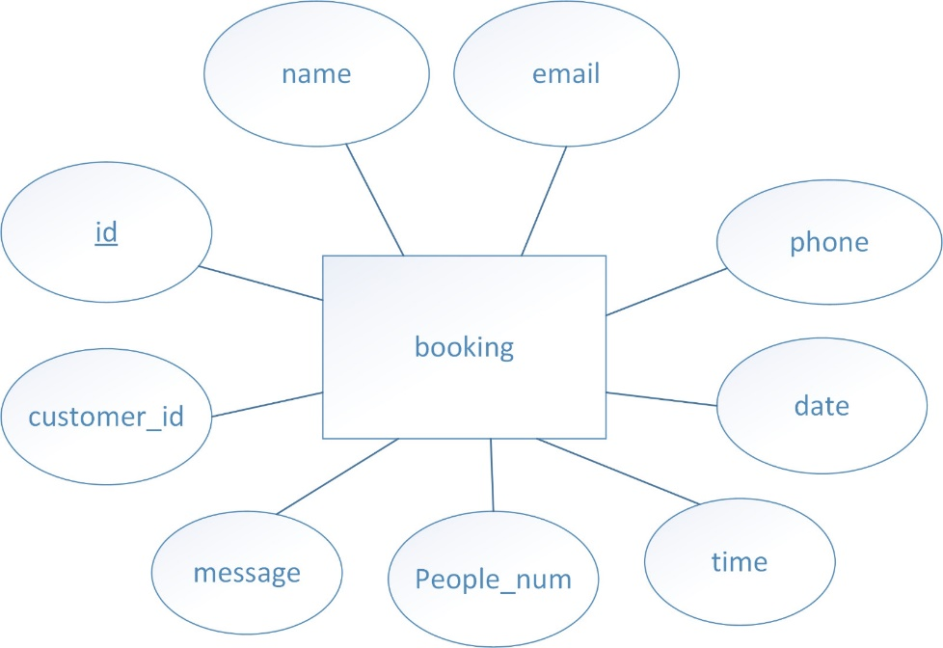

Figure 1: ERD of Table Booking

**3.1.1.2 ERD for Table Customers:**

In this entity relationship diagram relationship between the entity of database “Customers” and its attributes is shown.

Below mentioned shapes and lines are used in ERD:

* Shape **Rectangle** is used to represent the entity “Customers”.
* Shape **Oval** is used to represent the various attributes associated with the entity “Customers”.
* A **single line** is used to show the relationship between the entity “Customers” and its various attributes, specifying that the attribute is a property or characteristic of the entity.
* 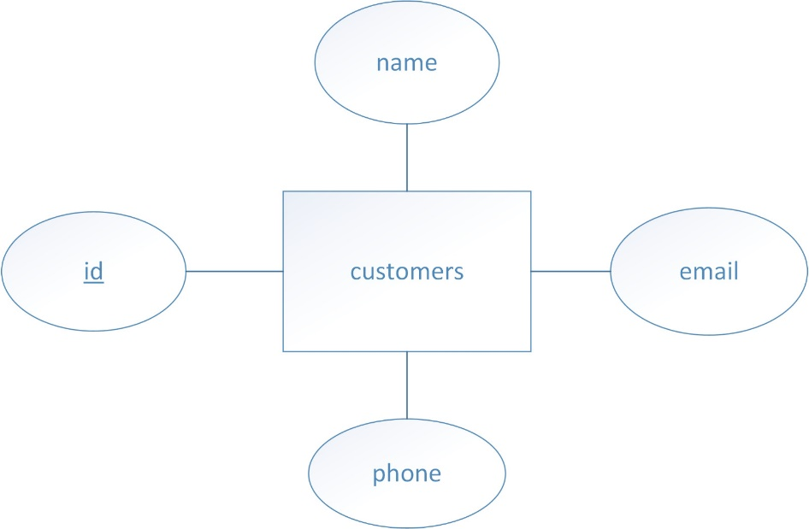An attribute **underlined** shows that it is a key attribute and it is a “primary key” component in a table.

Figure 2: ERD of Table Customers

**3.1.1.3 ERD for Table Chefs:**

In this entity relationship diagram relationship between the entity of database “Chefs” and its attributes is shown.

Below mentioned shapes and lines are used in ERD:

* Shape **Rectangle** is used to represent the entity “Chefs”.
* Shape **Oval** is used to represent the various attributes associated with the entity “Chefs”.
* A **single line** is used to show the relationship between the entity “Chefs” and its various attributes, specifying that the attribute is a property or characteristic of the entity.
* An attribute **underlined** shows that it is a key attribute and it is a “primary key” component in a table.

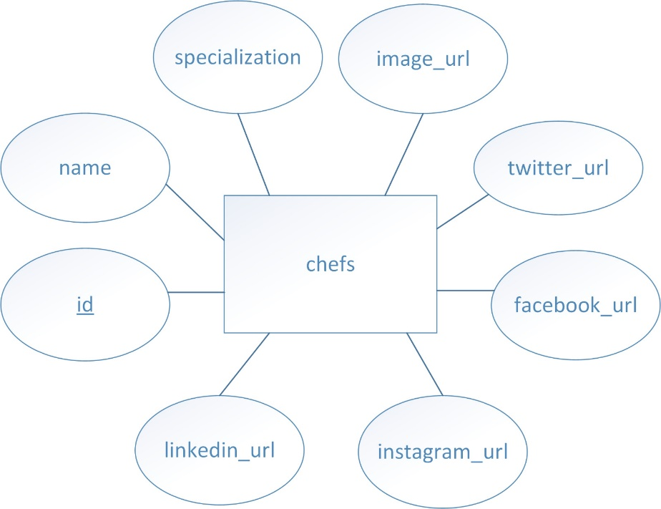

Figure 3: ERD of Table Chefs

**3.1.1.4 ERD for Table Contact_Us:**

In this entity relationship diagram relationship between the entity of database “contact_us” and its attributes is shown.

Below mentioned shapes and lines are used in ERD:

* Shape **Rectangle** is used to represent the entity “Contact_us”.
* Shape **Oval** is used to represent the various attributes associated with the entity “Contact_us”.
* A **single line** is used to show the relationship between the entity “Contact_us” and its various attributes, specifying that the attribute is a property or characteristic of the entity.
* An attribute **underlined** shows that it is a key attribute and it is a “primary key” component in a table. And in this table, attribute **id** is assigned the role of primary key.

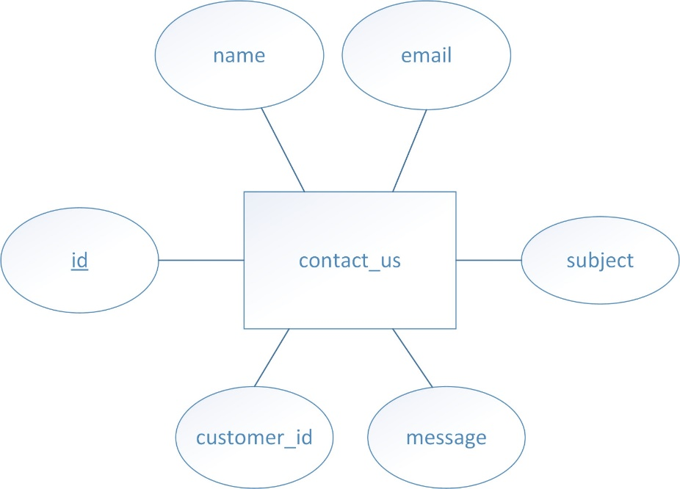

Figure 4: ERD of Table Contact_us

**3.1.1.5 ERD for Table Events:**

In this entity relationship diagram relationship between the entity of database “events” and its attributes is shown.

Below mentioned shapes and lines are used in ERD:

* Shape **Rectangle** is used to represent the entity “events”.
* Shape **Oval** is used to represent the various attributes associated with the entity “events”.
* A **single line** is used to show the relationship between the entity “events” and its various attributes, specifying that the attribute is a property or characteristic of the entity.
* An attribute **underlined** shows that it is a key attribute and it is a “primary key” component in a table.

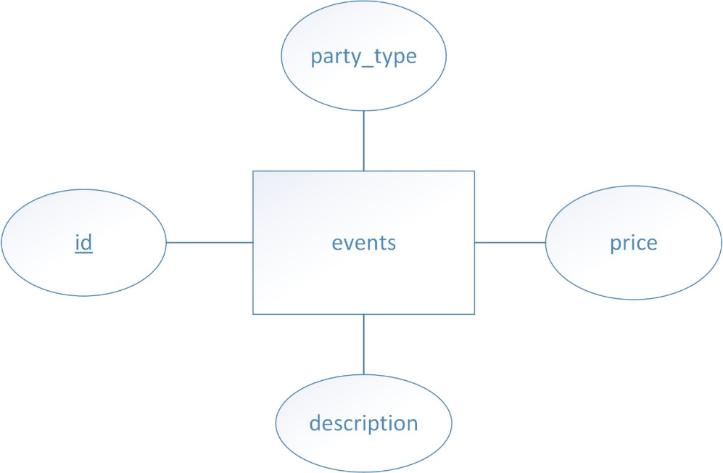

Figure 5: ERD of Table Events

**3.1.1.6 ERD for Table Payments:**

In this entity relationship diagram relationship between the entity of database “payments” and its attributes is shown.

Below mentioned shapes and lines are used in ERD:

* Shape **Rectangle** is used to represent the entity “payments”.
* Shape **Oval** is used to represent the various attributes associated with the entity “payments”.
* A **single line** is used to show the relationship between the entity “payments” and its various attributes, specifying that the attribute is a property or characteristic of the entity.
* An attribute **underlined** shows that it is a key attribute and it is a “primary key” component in a table.

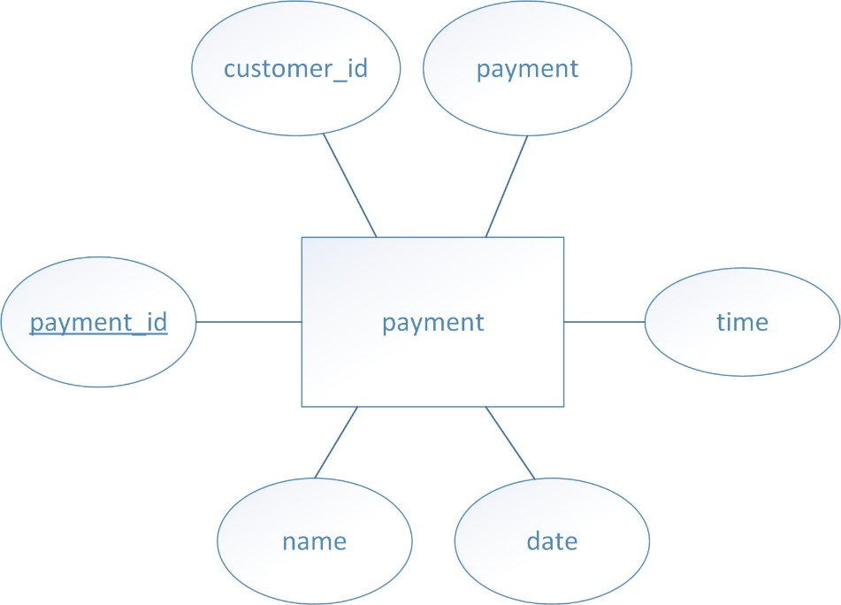

Figure 6: ERD of Table payments

**3.1.1.7 ERD for Table Testimonial:**

In this entity relationship diagram relationship between the entity of database “testimonial” and its attributes is shown.

Below mentioned shapes and lines are used in ERD:

* Shape **Rectangle** is used to represent the entity “testimonial”.
* Shape **Oval** is used to represent the various attributes associated with the entity “testimonial”.
* A **single line** is used to show the relationship between the entity “testimonial” and its various attributes, specifying that the attribute is a property or characteristic of the entity.
* An attribute **underlined** shows that it is a key attribute and it is a “primary key” component in a table.

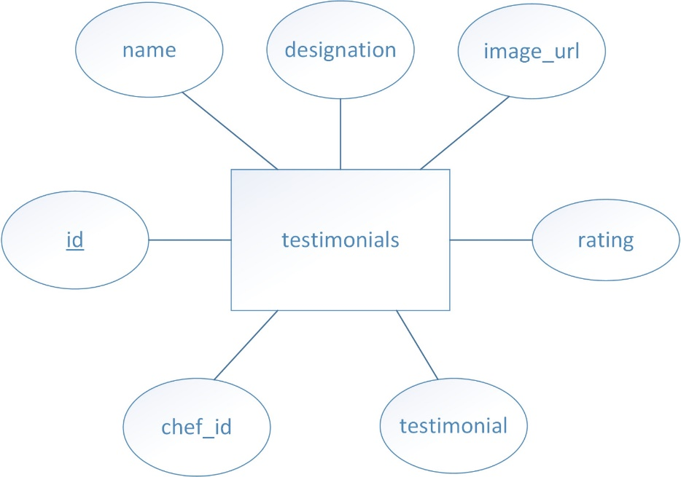

Figure 7: ERD of Table testimonial

**3.1.1.8 ERD for Table Users:**

In this entity relationship diagram relationship between the entity of database “testimonial” and its attributes is shown.

Below mentioned shapes and lines are used in ERD:

* Shape **Rectangle** is used to represent the entity “users”.
* Shape **Oval** is used to represent the various attributes associated with the entity “users”.
* A **single line** is used to show the relationship between the entity “users” and its various attributes, specifying that the attribute is a property or characteristic of the entity.
* An attribute **underlined** shows that it is a key attribute and it is a “primary key” component in a table.

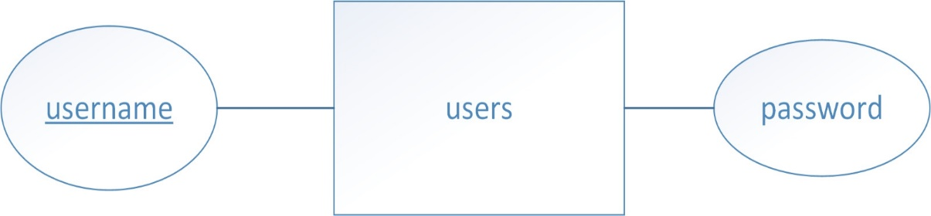

Figure 8: ERD of Table users

**3.1.2 ERD for Relationships:**

* A relationship in an ERD represents how two or more entities interact with each other.
* It shows the association between entities.
* In entity relationship diagram, **Diamonds** are used for representing the relationships and **lines** are used for connecting entities.

**3.1.2.1 ERD for Relationship between Customers and Contact_us:**

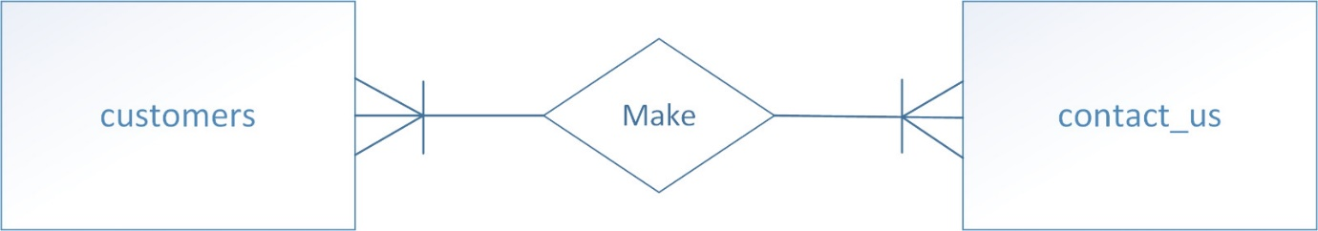

Figure 9: Relationship between customers and contact_us

**3.1.2.2 ERD for Relationship between Customers and Testimonials:**

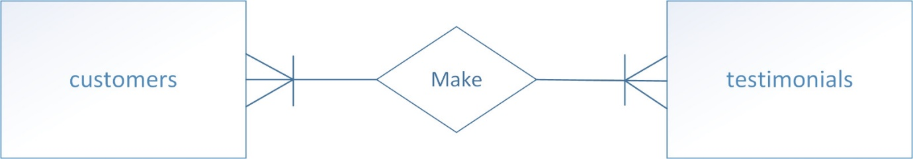

Figure 10: Relationship between customers and Testimonials

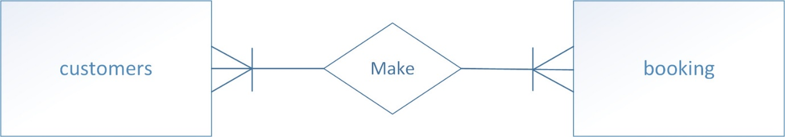**3.1.2.3 ERD for Relationship between Customers and Booking:**

Figure 11: Relationship between customers and bookings

**3.1.2.4 ERD for Relationship between Customers and Events:**

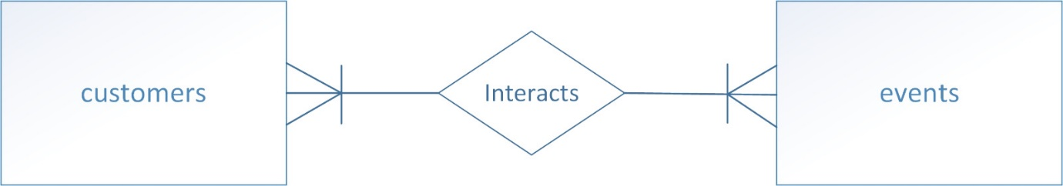

Figure 12: Relationship between customers and events

**3.1.2.5 ERD for Relationship between customers and payment:****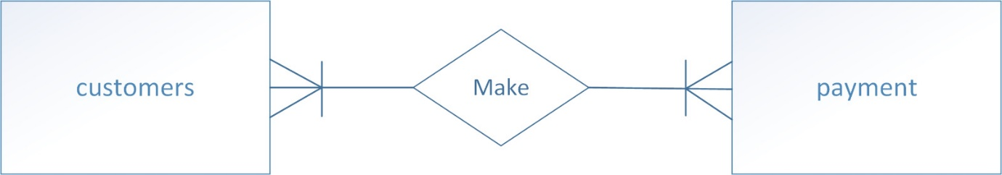**

Figure 13: Relationship between customers and payments

**3.1.3 ERD of Restaurant Management System:**

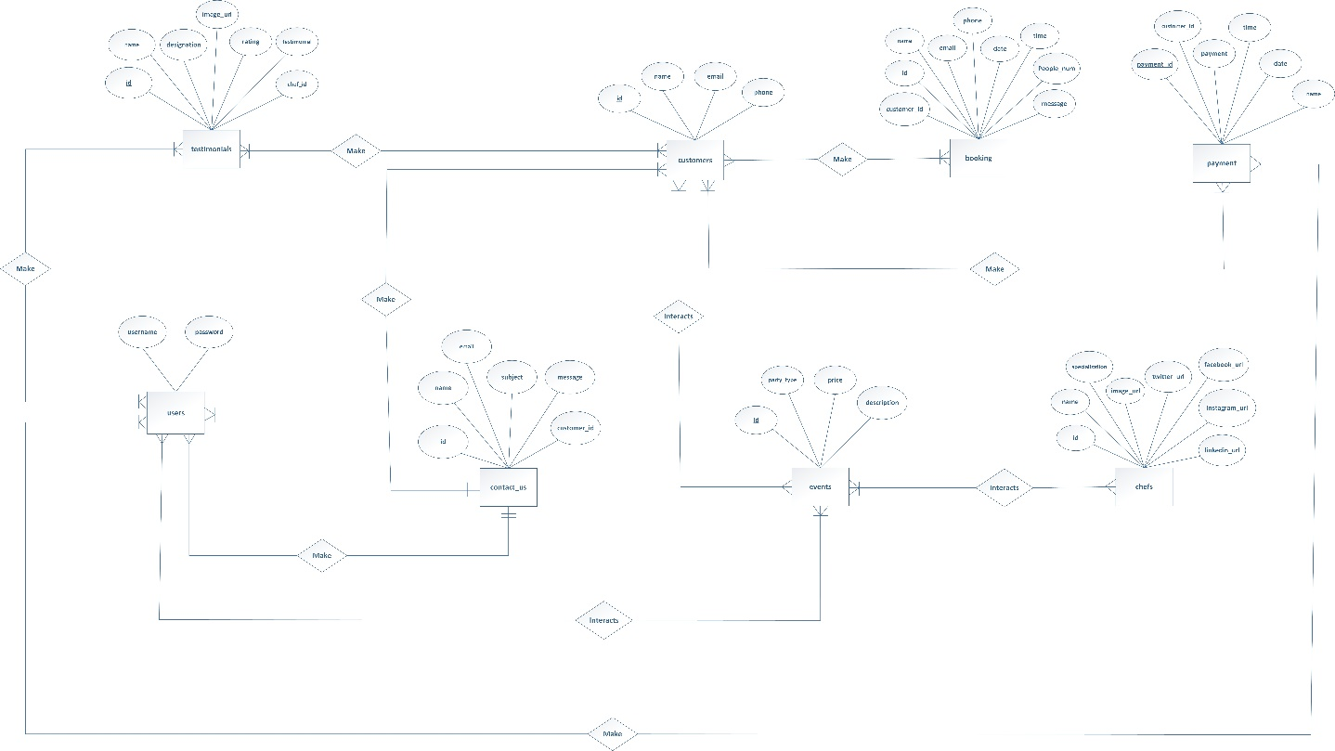

Figure 14: ERD of Restaurant Management System

# 3.1.4. Use Case:

A use case diagram for a Restaurant Management System illustrates the interactions between users (customers, waitstaff, managers) and the system's functionalities (reservations, order management, menu management, staff scheduling). It helps visualize system requirements and user interactions, aiding in clear communication and development planning.

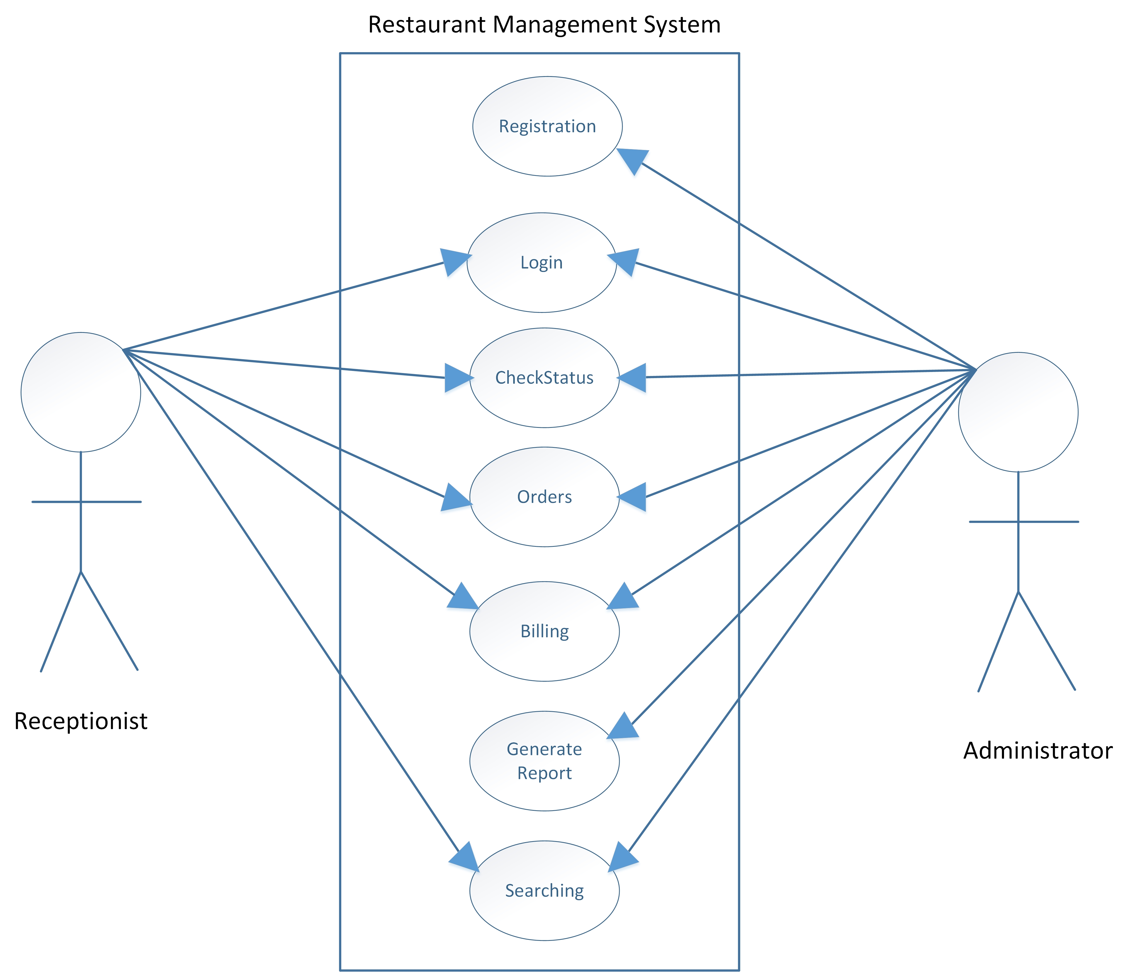

Figure 15: Use Case no 1

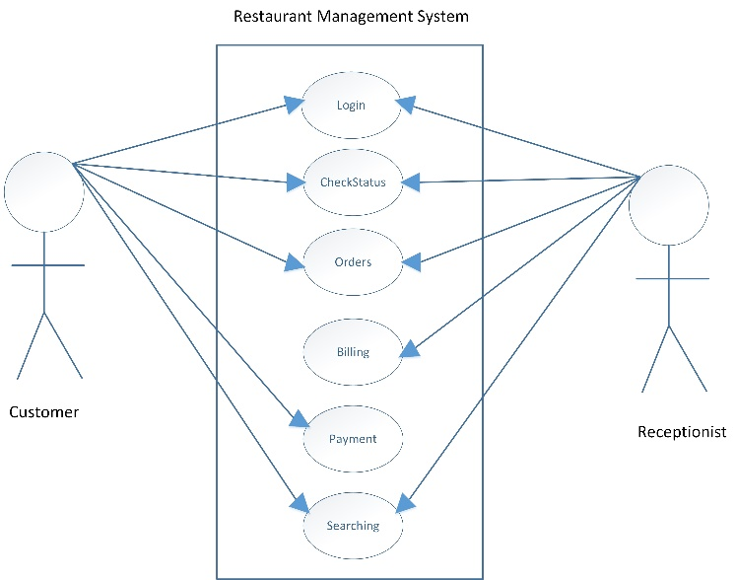

Figure 16: Use Case No 2

## 3.2. The Backend:

Creating the backend requires a plethora of things such as a Database Management Software like MySQL or Xampp. Other than that server side programming languages such as PHP and then other languages like SQL. The database server which will rum the DBMS and the physical or local storage in which the data is stored.

## 3.2.1. Creating the Database:

The next step in the process is to create the database. A simple Database Management Software (DBMS) can be easily used to create a database. The one that was used here is Xampp which is the most popular PHP development environment which typically includes MySQL as the database management system. Here's how the database was created using phpMyAdmin, which is bundled with XAMPP:

* **Start XAMPP Control Panel:**
* Opened the XAMPP Control Panel and start the Apache and MySQL services.
* **Access phpMyAdmin:**
* Accessed the phpMyAdmin interface by clicking on the Admin button on the Xampp control panel.
* **Create a New Database:**
* Once logged in, I saw the phpMyAdmin dashboard. On the left sidebar, I found a section labeled "Databases". I clicked on it.
* In the "Create database" field, I entered the name of my new database named “restaurant_management_system”.
* I clicked on the "Create" button to create the database.

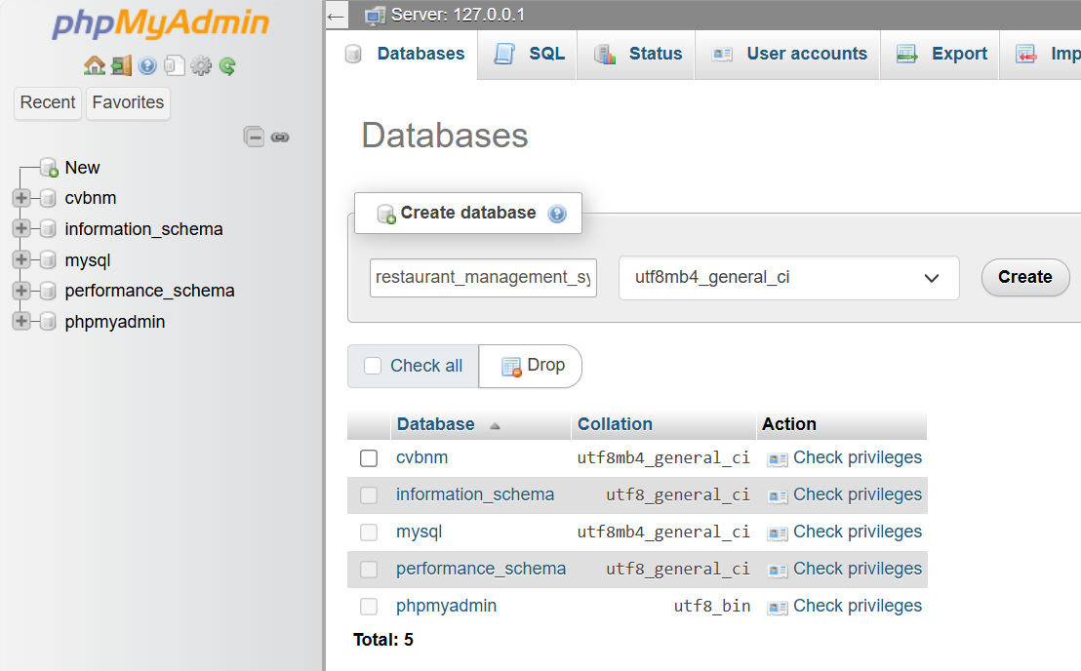

Figure 17: Creation of Database

* **Verifying Database Creation:**

After creating the database “restaurant_management_system” I saw it listed in the left sidebar.

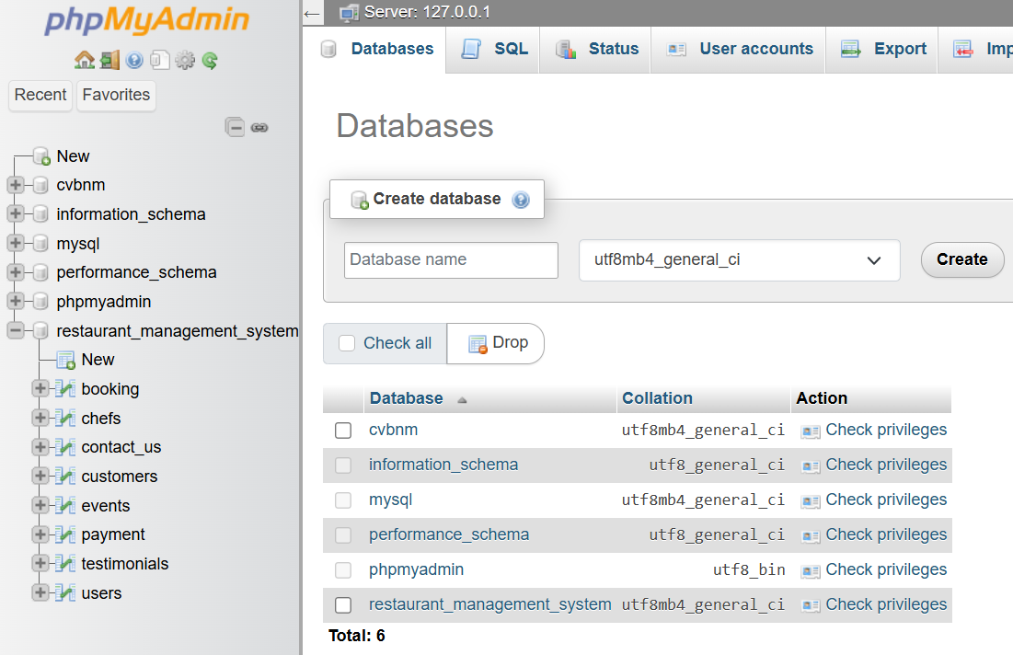

Figure 18: Database name appeared on left sidebar.

## 3.2.2. Creating Tables in the Database:

* I decided to create various tables in the database which are going to be used to store the relevant information related to various events that are going to be held.
* To create tables within the database, I clicked on the name of the newly created database in the left sidebar.
* For each column, I specified the name, data type, length, and any other attributes such as primary key, auto-increment, or default value.
* I clicked on the "Save" button to create the table.

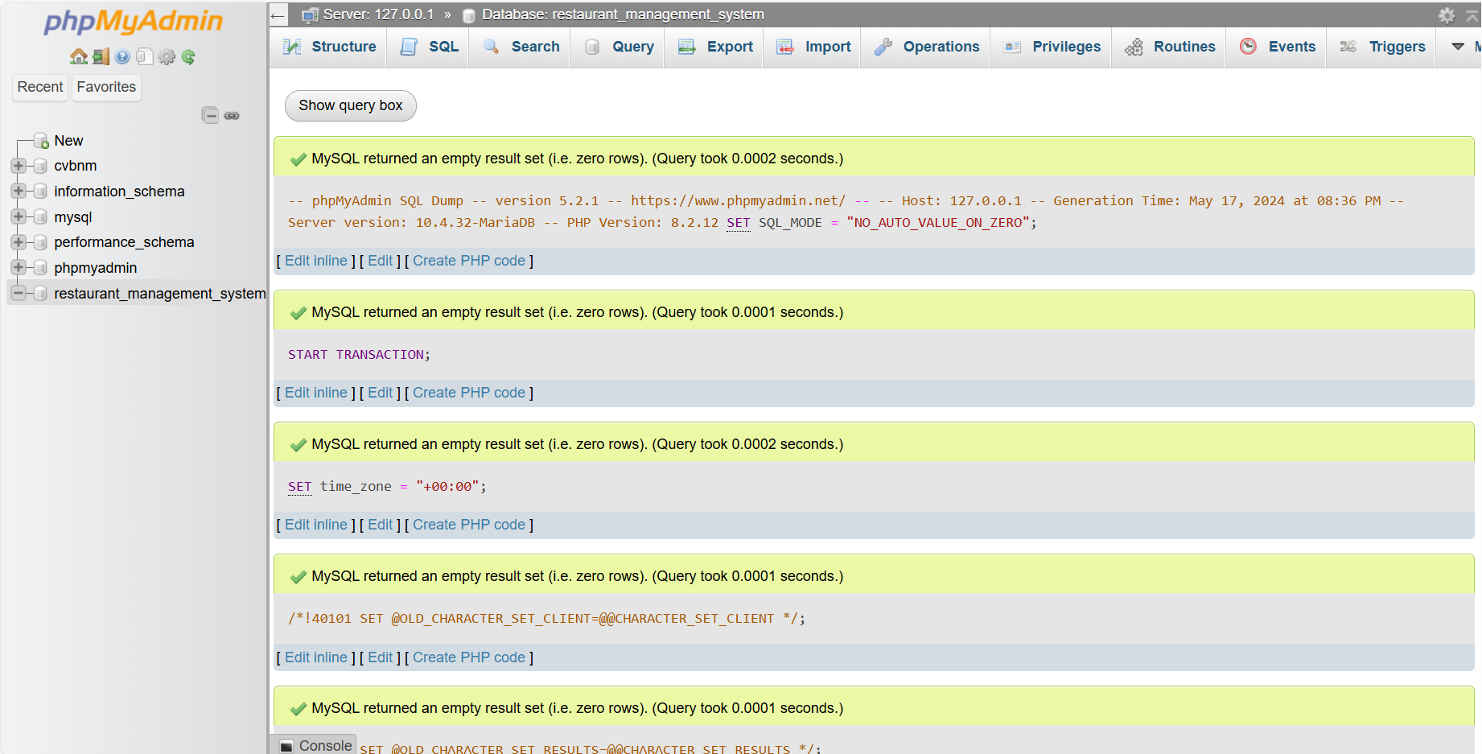

Figure 19: Creation of Tables.

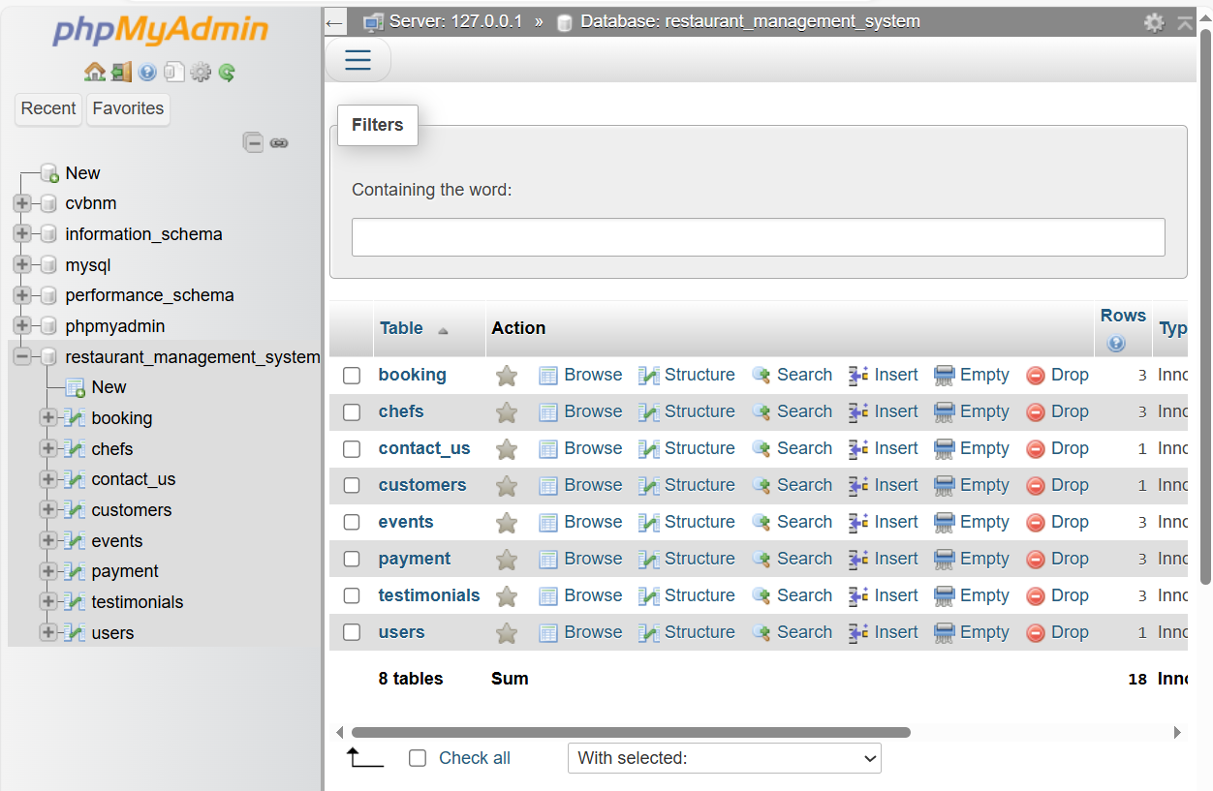

Figure 20: Table has been Created

* **Verify Table Creation:**

After creating a table, I saw it listed under the database in the left sidebar.

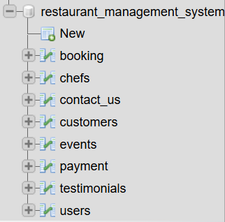

Figure 21: Tables listed under sidebar.

• **Data Entry:**

Write queries to enter data or information in each of the columns of the table or use the insert tab to insert data into each column to make a data entry.

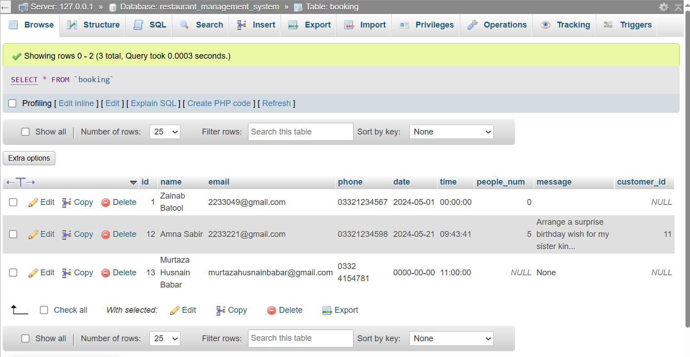

Figure 22: Booking Table with data inserted in it.

Using the same process as mentioned above I proceeded to create the remaining tables by entering the table name and number of columns and then I filled out all attribute name and their data types depending on whether the information to be inserted in them is either text, numerical or a mix of both. Data types like date and time were also used in cases where information about the date and time needed to be inserted. The following tables were created which is the same as the list of entities mentioned above:

* **Table: Booking**
* Booking_ id
* Customer name
* Email
* Phone
* dateTime
* People_num
* Message
* Customer_id
* **Table: Chefs**
* Customer_id
* Customer name
* Specilization
* Image_URL
* Twitter_URL
* Facebook_URL
* Instagram_URL
* Linkedin_URL
* **Table: Contact us**
* id
* name
* email
* subject
* message
* customer_id
* **Table: Customer**
* id
* name
* email
* phone
* **Table: Event**
* Id
* Party_ name
* Price
* Description
* **Table: Payment**
* Payment
* Time
* Date
* Name
* **Table: Testimonals**
* Id
* Name
* Designation
* Image_URL
* Rating
* Chef_id

**Table: Users**

* Username
* password

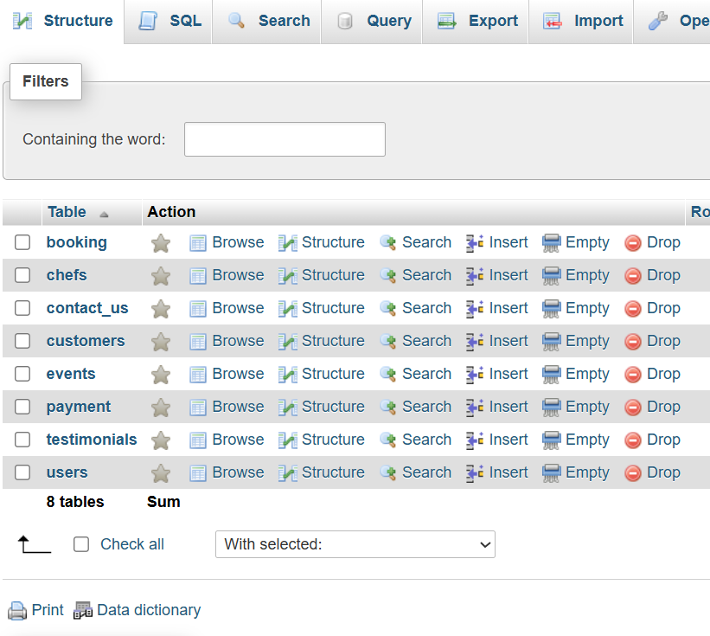

Figure 23: All the Tables in the database.

## Tables:

* **Booking:**

## Table Structure:

* **id**: An integer column that serves as the primary key for the table. It uniquely identifies each booking.
* **name**: A variable character string column (maximum 255 characters) that stores the name of the person making the booking. It can be NULL.
* **email**: A variable character string column (maximum 255 characters) that stores the email address of the person making the booking. It can be NULL.
* **phone**: A variable character string column (maximum 20 characters) that stores the phone number of the person making the booking. It can be NULL.
* **date**: A date column that stores the date of the booking. It can be NULL.
* **time**: A time column that stores the time of the booking. It can be NULL.
* **people_num**: An integer column that stores the number of people for whom the booking is made. It can be NULL.
* **message**: A text column that allows the person making the booking to include a message or special requests. It can be NULL.
* **customer_id**: An integer column that stores the ID of the customer making the booking. It can be NULL and serves as a potential foreign key to another table, such as a **customers** table, to link bookings to registered customers.

## Uses and Function of the Table:

1. **Storing Booking Information**: This table is designed to store detailed information about bookings made by customers, including their contact information, booking date and time, and number of people.
2. **Managing Reservations**: It allows businesses, such as restaurants or event venues, to manage reservations efficiently, keeping track of all bookings in a structured manner.
3. **Customer Contact**: The **email** and **phone** columns provide the necessary contact information to communicate with the person who made the booking, allowing for confirmations, cancellations, or special requests.
4. **Scheduling and Planning**: The **date** and **time** columns help in scheduling and planning resources and staff to accommodate bookings appropriately.
5. **Handling Special Requests**: The **message** column allows customers to include special requests or messages, helping businesses to personalize their service.
6. **Linking to Customer Profiles**: The **customer_id** column can link bookings to a **customers** table, enabling businesses to track and analyze customer behavior, preferences, and booking history.
7. **Data Analysis**: The table can be used for analyzing booking patterns, peak times, and customer demographics, aiding in business planning and marketing strategies.
8. **Automated Systems**: Integrating with automated booking systems, the information in this table can facilitate real-time updates and notifications for both customers and the business.

Overall, the **booking** table provides a comprehensive and organized way to handle bookings, enhancing customer service and operational efficiency for businesses that rely on reservations.

## Chefs:

## Table Structure:

* **id:** An integer column that serves as the primary key for the table. It uniquely identifies each chef.
* **name:** A variable character string column (maximum 255 characters) that stores the name of the chef. It can be NULL.
* **specialization:** A variable character string column (maximum 255 characters) that indicates the chef's area of culinary expertise (e.g., Italian cuisine, pastry chef). It can be NULL.
* **image_url:** A variable character string column (maximum 255 characters) that stores the URL to an image of the chef. It can be NULL.
* **twitter_url:** A variable character string column (maximum 255 characters) that contains the URL to the chef's Twitter profile. It can be NULL.
* **facebook_url:** A variable character string column (maximum 255 characters) that contains the URL to the chef's Facebook profile. It can be NULL.
* **instagram_url:** A variable character string column (maximum 255 characters) that contains the URL to the chef's Instagram profile. It can be NULL.
* **linkedin_url:** A variable character string column (maximum 255 characters) that contains the URL to the chef's LinkedIn profile. It can be NULL.

## Uses and Function of the Table

1. **Storing Chef Information:** This table is designed to store detailed information about chefs, including their names, specializations, and links to their social media profiles.
2. **Profile Management:** It allows for easy management of chef profiles within a culinary or restaurant management application. Each chef can be identified uniquely by the id.
3. **Displaying Profiles:** The image_url column enables the display of the chef's image in applications or websites, making the profiles more engaging.
4. **Social Media Integration:** The social media URL columns (twitter_url, facebook_url, instagram_url, linkedin_url) provide a way to link to the chef's social media profiles, facilitating greater connectivity and engagement with their audience.
5. **Filtering and Searching:** Users can filter or search for chefs based on their specialization, enabling applications to cater to specific user needs or preferences (e.g., finding a pastry chef).
6. **Data Analysis:** The table can be used for analyzing the reach and influence of chefs based on their social media presence and specialization areas.
7. **Marketing and Networking:** Businesses can use the information in this table to identify potential chefs for collaborations, events, or marketing campaigns based on their social media profiles and areas of expertise.

Overall, the chefs table provides a structured way to store and manage comprehensive information about chefs, facilitating various functionalities in culinary-related applications or platforms.

## Contact us:

## Table Structure:

* **id**: An integer column that serves as the primary key for the table. It uniquely identifies each contact submission.
* **name**: A variable character string column (maximum 255 characters) that stores the name of the person submitting the contact form. It can be NULL.
* **email**: A variable character string column (maximum 255 characters) that stores the email address of the person submitting the contact form. It can be NULL.
* **subject**: A variable character string column (maximum 255 characters) that stores the subject of the message. It can be NULL.
* **message**: A text column that contains the content of the message submitted through the contact form. It can be NULL.
* **customer_id**: An integer column that stores the ID of the customer submitting the contact form. It can be NULL and serves as a potential foreign key to another table, such as a **customers** table, to link submissions to registered customers.

**Uses and Function of the Table:**

1. **Storing Contact Submissions**: This table is designed to store detailed information about contact form submissions from users, including their name, email, subject, and message.
2. **Managing Customer Inquiries**: It allows businesses to manage and track inquiries and messages from customers or potential customers in an organized manner.
3. **Customer Contact**: The **email** column provides the necessary contact information to respond to the person who submitted the form, facilitating effective communication.
4. **Categorizing Inquiries**: The **subject** column helps in categorizing and prioritizing inquiries, enabling quicker and more relevant responses.
5. **Handling Messages**: The **message** column allows users to convey their concerns, feedback, or questions, providing valuable input for the business.
6. **Linking to Customer Profiles**: The **customer_id** column can link contact submissions to a **customers** table, allowing businesses to see the full history of interactions with a particular customer, including previous inquiries and responses.
7. **Improving Customer Service**: By storing and managing contact form submissions, businesses can ensure that all inquiries are addressed in a timely and organized manner, improving overall customer service.
8. **Data Analysis**: The table can be used to analyze common issues or frequently asked questions, helping businesses to improve their services or FAQs based on customer feedback.
9. **Automated Systems**: Integrating with customer relationship management (CRM) systems, the information in this table can facilitate automated acknowledgment of receipt and tracking of inquiries.

Overall, the **contact_us** table provides a structured and efficient way to handle contact form submissions, enhancing customer interaction and support capabilities for businesses.

* **Customers:**

## Table Structure:

* **id**: An integer column that serves as the primary key for the table. It uniquely identifies each customer.
* **name**: A variable character string column (maximum 255 characters) that stores the name of the customer. It can be NULL.
* **email**: A variable character string column (maximum 255 characters) that stores the email address of the customer. It can be NULL.
* **phone**: A variable character string column (maximum 20 characters) that stores the phone number of the customer. It can be NULL.

## Uses and Function of the Table:

1. **Storing Customer Information**: This table is designed to store detailed information about customers, including their names, email addresses, and phone numbers.
2. **Managing Customer Profiles**: It allows businesses to manage and keep track of their customers in an organized manner, facilitating easy access to customer information.
3. **Contact Information**: The **email** and **phone** columns provide the necessary contact details to communicate with customers for various purposes, such as marketing, support, or follow-up.
4. **Linking to Other Tables**: The **id** column can be used as a foreign key in other tables, such as **booking** or **contact_us**, to link bookings or inquiries to specific customers, enabling a comprehensive view of customer interactions.
5. **Customer Relationship Management**: This table supports customer relationship management (CRM) efforts by storing essential customer details, aiding in personalized communication and service.
6. **Data Analysis**: The table can be used for analyzing customer demographics and behavior, helping businesses to tailor their services and marketing strategies to better meet customer needs.
7. **Customer Segmentation**: Businesses can segment customers based on various criteria stored in this table, such as contact frequency or customer value, to target different customer groups more effectively.
8. **Improving Customer Service**: By maintaining detailed customer information, businesses can enhance their customer service, ensuring that they have the necessary information to address customer needs and preferences.

Overall, the **customers** table provides a foundational structure for storing and managing customer information, playing a critical role in various business operations, including marketing, customer service, and data analysis.

## Events:

## Table Structure:

* **id**: An integer column that serves as the primary key for the table. It uniquely identifies each event.
* **party_type**: A variable character string column (maximum 255 characters) that stores the type of party or event (e.g., wedding, birthday, corporate event). It can be NULL.
* **price**: A decimal column (with a precision of 8 and a scale of 2) that stores the price associated with the event. It can be NULL.
* **description**: A text column that contains a detailed description of the event. It can be NULL.

## Uses and Function of the Table:

1. **Storing Event Information**: This table is designed to store detailed information about different events, including the type of event, its price, and a description.
2. **Managing Event Types**: It allows businesses to manage various types of events they offer, providing an organized way to categorize and describe them.
3. **Pricing Information**: The **price** column provides information on the cost associated with each event type, aiding in financial planning and customer quotations.
4. **Event Descriptions**: The **description** column allows for detailed descriptions of each event type, helping customers understand what each event includes and what to expect.
5. **Linking to Other Tables**: The **id** column can be used as a foreign key in other tables, such as a bookings or registrations table, to link specific events to customer bookings or registrations.
6. **Customer Decision-Making**: By storing detailed information about different event types and their prices, the table helps customers make informed decisions about which event type best suits their needs and budget.
7. **Marketing and Promotions**: The information in this table can be used to market and promote different event types, highlighting their features and pricing to attract customers.
8. **Event Planning**: Businesses can use the information in this table to plan and organize events more efficiently, ensuring all necessary details are documented and accessible.
9. **Data Analysis**: The table can be used to analyze trends in event bookings and preferences, helping businesses to tailor their offerings and improve their services based on customer demand.

Overall, the **events** table provides a comprehensive and organized way to manage information about various event types, facilitating efficient event planning, customer decision-making, and business operations.

* **Payment:**

## Table Structure:

* **payment_id**: An integer column that serves as the primary key for the table. It uniquely identifies each payment.
* **customer_id**: An integer column that stores the ID of the customer making the payment. It is NOT NULL and can serve as a foreign key to link to the **customers** table.
* **payment**: A decimal column (with a precision of 10 and a scale of 2) that stores the amount of the payment. It is NOT NULL.
* **time**: A time column that stores the time the payment was made. It is NOT NULL.
* **date**: A date column that stores the date the payment was made. It is NOT NULL.
* **name**: A variable character string column (maximum 255 characters) that stores the name of the person making the payment. It is NOT NULL.

## Uses and Function of the Table:

1. **Storing Payment Information**: This table is designed to store detailed information about payments made by customers, including payment amounts, times, dates, and customer details.
2. **Managing Financial Transactions**: It allows businesses to manage and track financial transactions efficiently, ensuring all payments are recorded accurately.
3. **Linking to Customer Profiles**: The **customer_id** column links each payment to a specific customer in the **customers** table, providing a comprehensive view of customer transactions.
4. **Tracking Payment History**: The **payment**, **time**, and **date** columns provide detailed records of when and how much was paid, facilitating easy tracking of payment history.
5. **Customer Identification**: The **name** column stores the name of the person making the payment, which can help in identifying the payer, especially in cases where the payment is made by someone other than the customer (e.g., a family member).
6. **Financial Reporting**: The table can be used to generate financial reports, helping businesses to analyze revenue, track outstanding payments, and manage their finances.
7. **Auditing and Accountability**: Detailed payment records aid in auditing processes, ensuring that all transactions are accounted for and reducing the risk of financial discrepancies.
8. **Customer Service**: Having detailed payment information readily available helps in addressing customer inquiries and resolving any payment-related issues efficiently.
9. **Data Analysis**: The table can be used to analyze payment trends, such as peak payment times and common payment amounts, aiding in financial planning and strategy development.

Overall, the **payment** table provides a structured and efficient way to manage and track customer payments, supporting various financial and operational functions within a business.

## Testimonials:

## Table Structure:

* **id**: An integer column that serves as the primary key for the table. It uniquely identifies each testimonial.
* **name**: A variable character string column (maximum 255 characters) that stores the name of the person giving the testimonial. It can be NULL.
* **designation**: A variable character string column (maximum 255 characters) that stores the designation or job title of the person giving the testimonial. It can be NULL.
* **image_url**: A variable character string column (maximum 255 characters) that stores the URL to an image of the person giving the testimonial. It can be NULL.
* **rating**: An integer column that stores the rating given by the person, typically on a scale (e.g., 1 to 5). It can be NULL.
* **testimonial**: A text column that contains the content of the testimonial. It can be NULL.
* **chef_id**: An integer column that stores the ID of the chef associated with the testimonial. It can be NULL and serves as a potential foreign key to link to the **chefs** table.

## Uses and Function of the Table:

1. **Storing Testimonials**: This table is designed to store detailed information about testimonials provided by customers or clients, including their name, designation, image, rating, and the testimonial content.
2. **Managing Feedback**: It allows businesses to manage and organize feedback from customers, which can be used for promotional purposes and improving services.
3. **Linking to Chefs**: The **chef_id** column can link each testimonial to a specific chef in the **chefs** table, showcasing feedback and ratings for individual chefs.
4. **Displaying Testimonials**: The **image_url** column enables the display of the customer's image alongside their testimonial on websites or promotional materials, adding a personal touch.
5. **Rating System**: The **rating** column provides a quantitative measure of customer satisfaction, which can be used to assess and compare performance.
6. **Promotional Use**: The information in this table can be used in marketing campaigns to highlight positive feedback and ratings from satisfied customers.
7. **Customer Trust**: Displaying genuine testimonials with customer names, designations, and images can help build trust and credibility with potential customers.
8. **Service Improvement**: The feedback provided in the testimonials can offer valuable insights into what customers appreciate or what needs improvement, helping businesses enhance their services.
9. **Data Analysis**: The table can be used to analyze trends in customer feedback, such as common themes in testimonials or average ratings, aiding in strategic decision-making.

Overall, the **testimonials** table provides a structured way to capture, manage, and utilize customer feedback, supporting promotional efforts and service improvement initiatives.

## Users:

## Table Structures:

* **username**: A variable character string column (maximum 255 characters) that serves as the primary key for the table. It uniquely identifies each user and is NOT NULL.
* **password**: A variable character string column (maximum 30 characters) that stores the user's password. It is NOT NULL.

## Uses and Function of the Table:

1. **User Authentication**: This table is designed to store usernames and passwords for user authentication purposes, allowing users to log into a system securely.
2. **Managing User Accounts**: It allows businesses or applications to manage user accounts, keeping track of usernames and associated passwords.
3. **Access Control**: By verifying usernames and passwords, the table helps control access to certain features, areas, or data within an application.
4. **User Identification**: The **username** column serves as a unique identifier for each user, ensuring that each account is distinct.
5. **Security Considerations**: The **password** column stores the user's password, though typically in practice, passwords should be hashed and not stored in plain text to enhance security.
6. **Account Recovery**: The table can support account recovery processes by verifying user identities through their username.
7. **User Management**: Administrators can use the table to add, modify, or delete user accounts as needed, facilitating user management within the system.
8. **Integration with Other Tables**: The **username** column can be used to link with other tables that store additional user-related information, such as profiles or activity logs.
9. **Data Integrity**: By enforcing the NOT NULL constraint on both columns, the table ensures that every user account has a username and a password, maintaining data integrity.

## Security Note:

While this table structure includes plain text storage for passwords, it is important to implement additional security measures in practice, such as:

* **Password Hashing**: Store hashed versions of passwords instead of plain text to protect user credentials.
* **Salted Hashing**: Use salt values to add an extra layer of security to password hashes.
* **Encryption**: Consider encrypting sensitive data to prevent unauthorized access.

Overall, the **users** table provides a basic structure for managing user authentication and access control within an application, though it should be implemented with proper security practices to protect user information.

## Use of Keys:

This SQL script adds primary keys, foreign keys, and auto-increment properties to various tables in a database, ensuring that each table has a unique identifier for its records and establishing relationships between tables.

**1. Booking Table**

* **Primary Key**: Adds a primary key to the **id** column.
* **Auto-Increment**: Modifies the **id** column to be an auto-incrementing integer, starting with a value of 14.

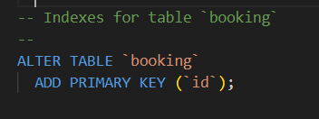

Figure 24: Indexes for Booking table

**2. Chefs Table**

* **Primary Key**: Adds a primary key to the **id** column.

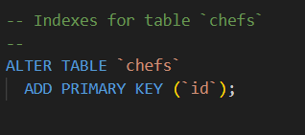

Figure 25: Indexes for Chefs table

**3. Contact_Us Table**

* **Primary Key**: Adds a primary key to the **id** column.
* **Foreign Key**: Adds an index on the **customer_id** column to facilitate the creation of a foreign key relationship with the **customers** table.

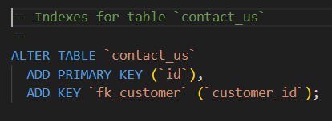

Figure 26: Indexes for Contact_us table

**4. Customers Table**

* **Primary Key**: Adds a primary key to the **id** column.
* **Auto-Increment**: Modifies the **id** column to be an auto-incrementing integer, starting with a value of 2.

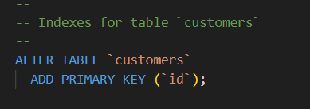

Figure 27: Indexes for Customers table

**5. Events Table**

* **Primary Key**: Adds a primary key to the **id** column.

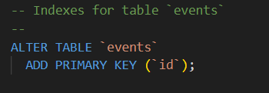

Figure 28: Indexes for Events table

**6. Payment Table**

* **Primary Key**: Adds a primary key to the **payment_id** column.
* **Foreign Key**: Adds an index on the **customer_id** column to facilitate the creation of a foreign key relationship with the **customers** table.

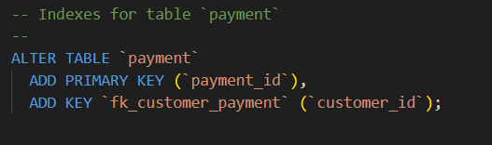

Figure 29: Indexes for Payment table

**7. Testimonials Table**

* **Primary Key**: Adds a primary key to the **id** column.
* **Foreign Key**: Adds an index on the **chef_id** column to facilitate the creation of a foreign key relationship with the **chefs** table.

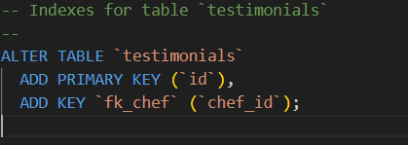

Figure 30: Indexes for Testimonials table

**8. Users Table**

* **Primary Key**: Adds a primary key to the **username** column.

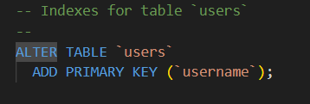

Figure 31: Indexes for Users table

## Detailed Breakdown

1. **Primary Keys**

* A primary key uniquely identifies each record in a table.
* Adding a primary key ensures that each record is unique and provides an efficient way to access data.

1. **Foreign Keys and Indexes**

* Indexes on columns like **customer_id** and **chef_id** prepare the table for foreign key relationships, which enforce referential integrity between tables.
* For example, **contact_us** and **payment** tables can reference **customer_id** from the **customers** table, linking customer inquiries and payments to specific customers.
* The **testimonials** table can reference **chef_id** from the **chefs** table, linking testimonials to specific chefs.

1. **Auto-Increment**

* Auto-incrementing columns automatically generate unique values for each new record, starting from a specified number.
* For the **booking** table, **id** starts from 14.
* For the **customers** table, **id** starts from 2.
* This ensures that each new record gets a unique identifier without manual intervention.

## Benefits

* **Data Integrity**: Primary keys ensure that each record is unique, and foreign keys maintain referential integrity between tables.
* **Efficiency**: Indexes improve the speed of data retrieval operations.
* **Automation**: Auto-increment columns automatically handle the generation of unique identifiers, simplifying the process of adding new records.
* **Relationship Mapping**: Establishing foreign key relationships helps in maintaining a structured and related dataset, which is crucial for relational databases.

By implementing these constraints and properties, the script ensures that the database structure is robust, efficient, and capable of maintaining the integrity and relationships of the data it stores.

1. **Key Constraints:**

This SQL script adds foreign key constraints to several tables in the database, establishing relationships between them and ensuring referential integrity. Foreign key constraints ensure that the value in a column (or a set of columns) matches values in the referenced primary key column(s) of another table.

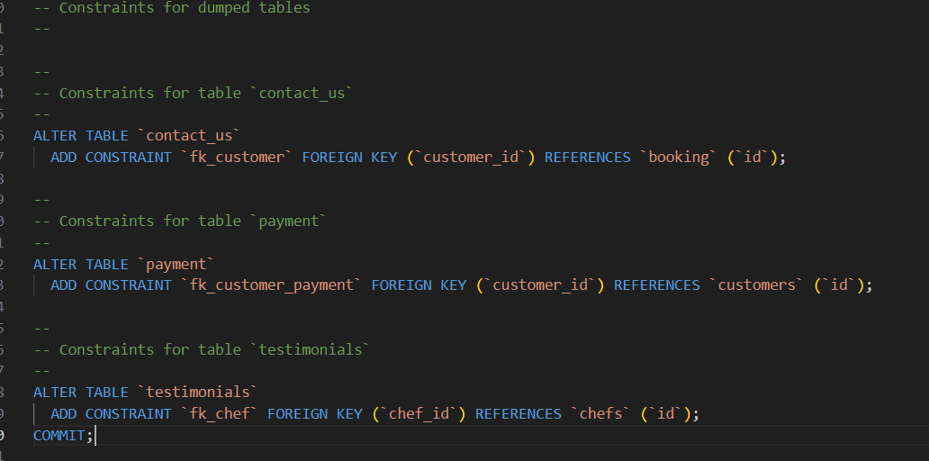

Figure 32: Constraints for tables

1. **Contact_us Table**

* **Foreign Key Constraint**: Adds a foreign key constraint named **fk_customer** on the **customer_id** column.
* **Referenced Table**: **booking**
* **Referenced Column**: **id**
* **Purpose**: Ensures that every **customer_id** in the **contact_us** table corresponds to an existing **id** in the **booking** table, linking contact submissions to specific bookings.

1. **Payment Table**

* **Foreign Key Constraint**: Adds a foreign key constraint named **fk_customer_payment** on the **customer_id** column.
* **Referenced Table**: **customers**
* **Referenced Column**: **id**
* **Purpose**: Ensures that every **customer_id** in the **payment** table corresponds to an existing **id** in the **customers** table, linking payments to specific customers.

1. **Testimonials Table**

* **Foreign Key Constraint**: Adds a foreign key constraint named **fk_chef** on the **chef_id** column.
* **Referenced Table**: **chefs**
* **Referenced Column**: **id**
* **Purpose**: Ensures that every **chef_id** in the **testimonials** table corresponds to an existing **id** in the **chefs** table, linking testimonials to specific chefs.

## Benefits of Foreign Key Constraints:

* **Referential Integrity**: Foreign key constraints ensure that relationships between tables remain consistent. For example, a contact submission cannot reference a non-existent booking, a payment cannot reference a non-existent customer, and a testimonial cannot reference a non-existent chef.
* **Data Accuracy**: By enforcing that referenced records exist, foreign key constraints help maintain accurate and reliable data.
* **Cascading Actions**: Depending on how the foreign key constraints are set up (not shown in this script), cascading actions such as **ON DELETE CASCADE** or **ON UPDATE CASCADE** can be defined to automatically manage related records, simplifying database maintenance.
* **Enhanced Query Performance**: Properly indexed foreign key columns can enhance the performance of joins and queries involving related tables.

## Summary of the Script

* The script adds foreign key constraints to the **contact_us**, **payment**, and **testimonials** tables.
* These constraints enforce the relationships:
* **contact_us.customer_id** must exist in **booking.id**.
* **payment.customer_id** must exist in **customers.id**.
* **testimonials.chef_id** must exist in **chefs.id**.

## The Frontend:

## Define Requirements:

Before developing the front end of the Restaurant Management System (RMS), it was essential to understand the specific needs of the users, including restaurant customers, and chefs. We determined the functionalities the front end should provide, such as table reservations, menu display, and contact_us.

## Design UI/UX:

Next, we created several wireframes or mockups of the user interface, focusing on the layout, navigation flow, and visual elements to ensure the front end is intuitive and user-friendly. Additionally, I selected a color scheme that aligns with the restaurant's branding.

## Choose Technologies:

I then selected the appropriate technologies for building the front end, including HTML, CSS and Js for the web-based application. These technologies were chosen for their flexibility and compatibility with various devices.

## Develop Front End:

I wrote the code to implement the UI design using the chosen technologies. This involved creating forms for reservations and orders, input fields for menu items, buttons for submitting orders, and other UI components to interact with the database.

## **Connect to Database:**

Then implement the functionality to connect the front end to the database. This typically involves using APIs or libraries provided by the database management system (DBMS) to establish connections, execute queries, and retrieve or update data.

## **Handle CRUD Operations:**

Then Implement Create, Read, Update, and Delete (CRUD) operations within the front end interface. This allows users to add new records, view existing data, modify records, and delete records as needed.

## **Error Handling:**

I then implemented error handling mechanisms to gracefully manage errors that may occur during database operations or user interactions. Provided informative error messages to users to help them understand and resolve issues.

## Testing:

Thoroughly test the front end interface to ensure that it works as expected. Tested whether all the links were working properly or not. Tested the side bar and made sure everything was running smoothly.

## **Iterate and Improve:**

I gathered feedback from users and stakeholders, and make necessary improvements to the front end based on their feedback. Continuously iterate on the design and functionality to enhance the user experience and address any issues or concerns.

## The Final Product:

After going through all the above mentioned steps, the final product has been made and its user interface and all the respective tables of the Restaurant Management System is displayed below.

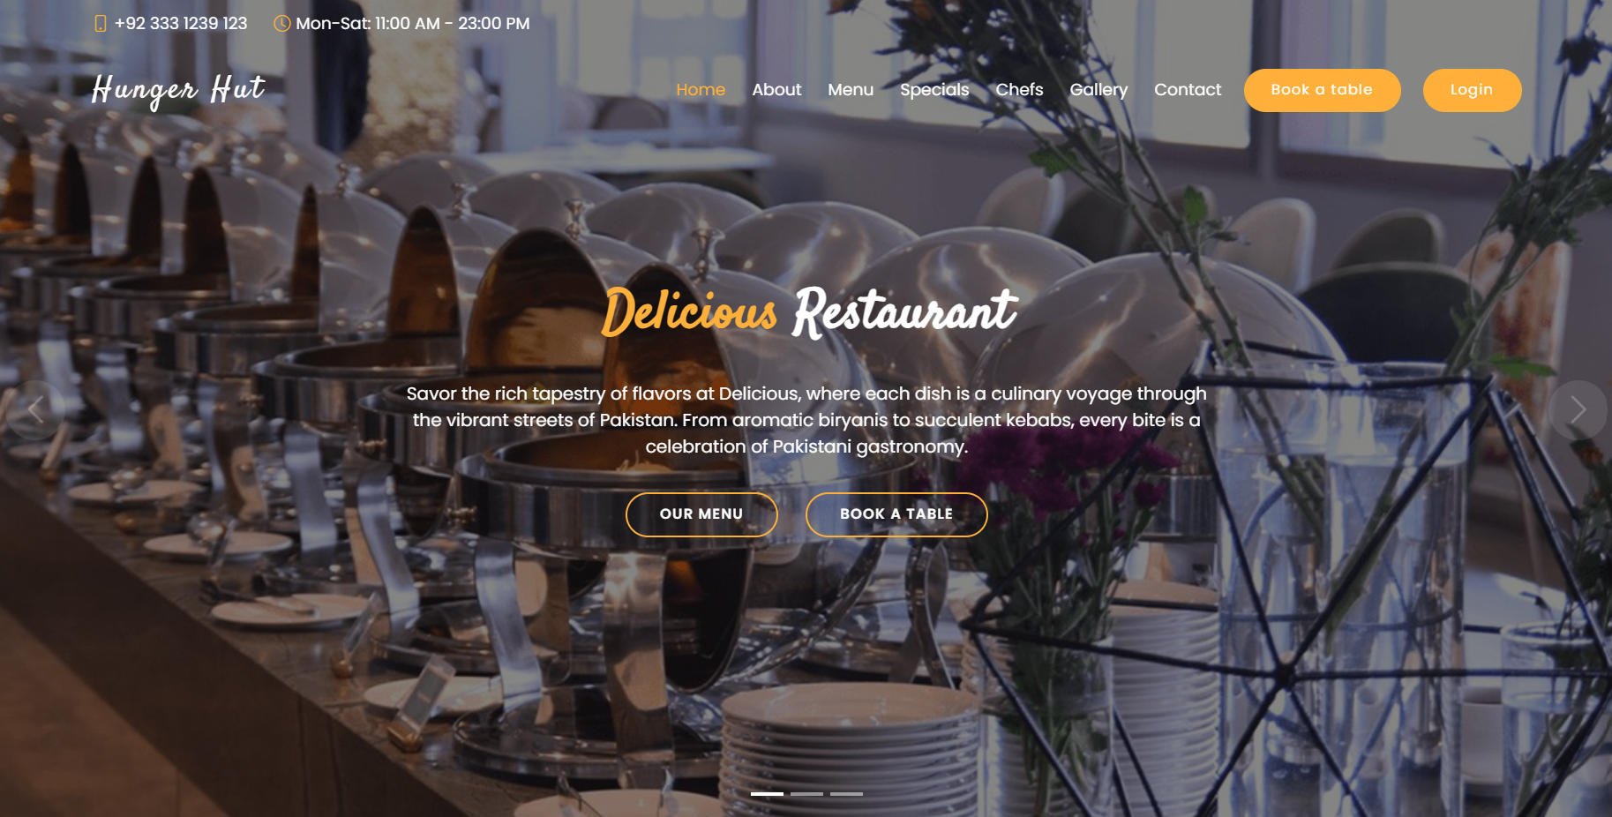

Figure 33: The User Interface

## **The User Interface:**

The user interface allows the users to interact and open all the available tables. It basically introduces the user to the Restaurant Management System and sets the first impression conveying professionalism. It is essentially and completely acts as the main, introductory page of the management system.

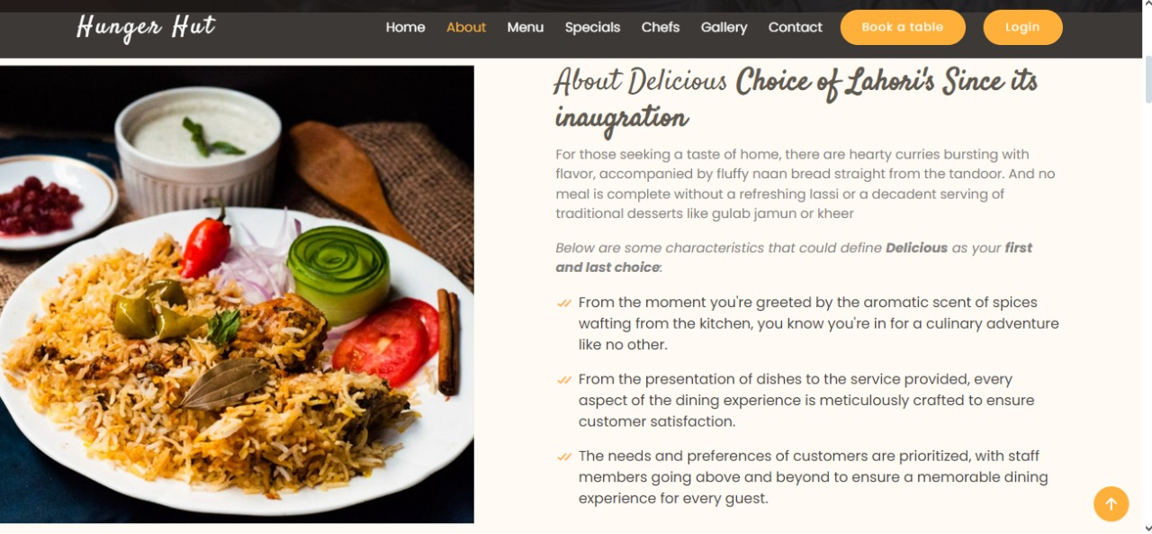

Figure 34: About Interface

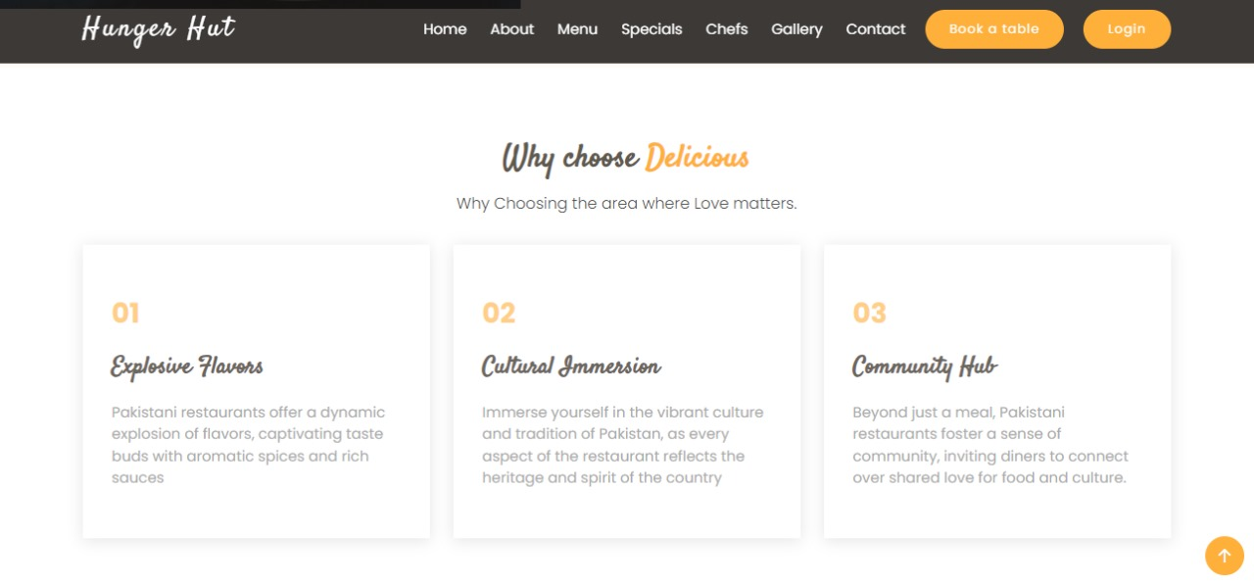

Figure 35: Reasons to choose Hunger Hut

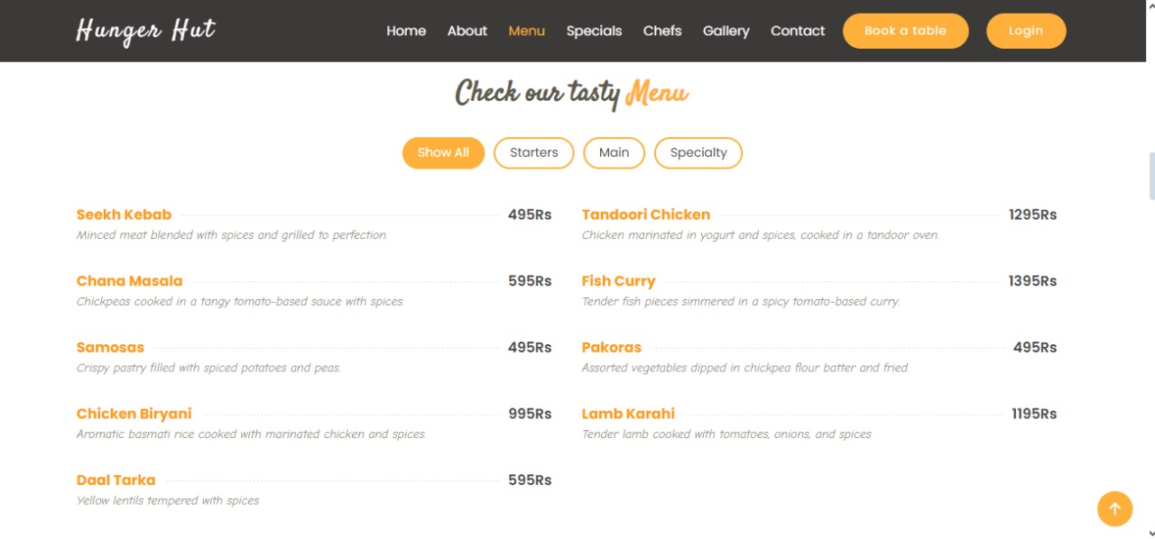

Figure 36: Menu Page

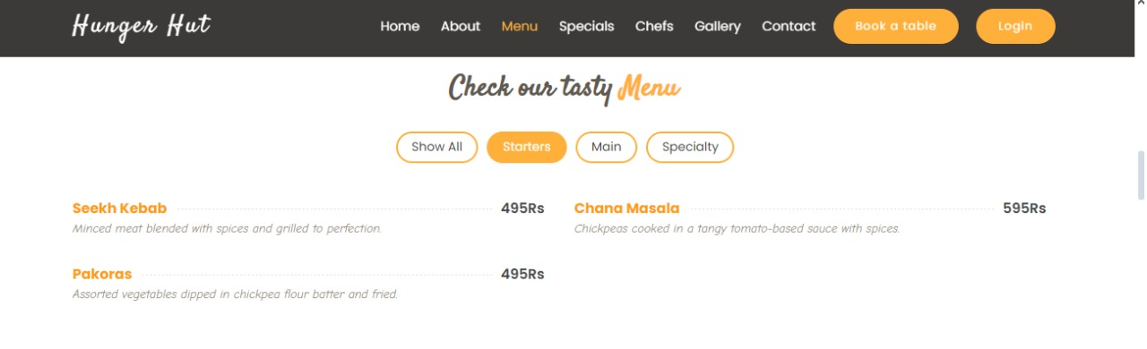

Figure 37: Starters in Menu

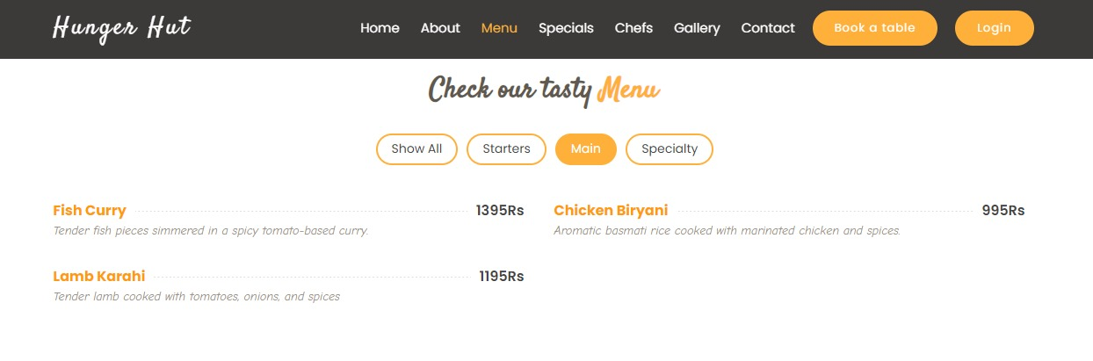

Figure 38: Main Course Section in menu

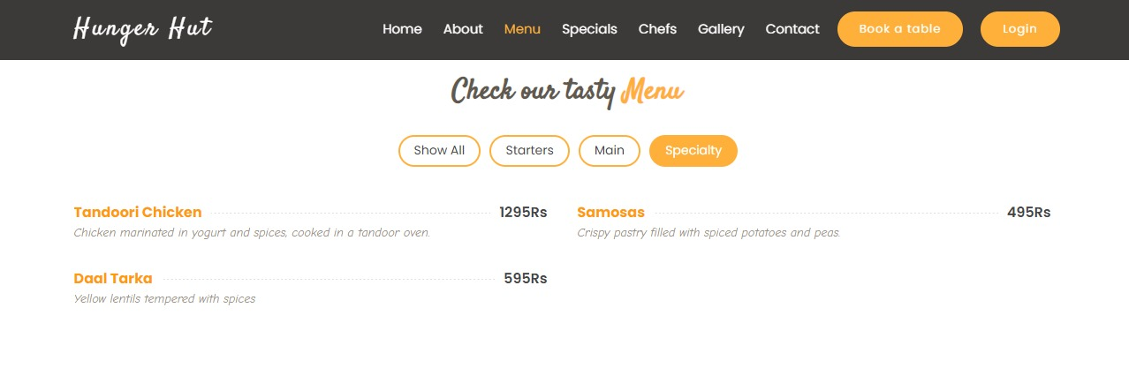

Figure 39: Specialty Section in menu

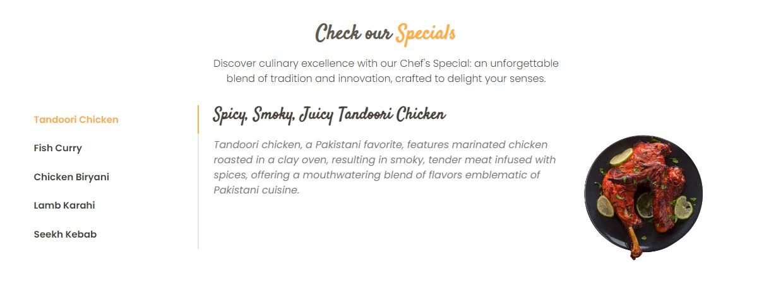

Figure 40: Hunger hut Specials



Figure 41: About our Chefs



Figure 42: Various Testimonials

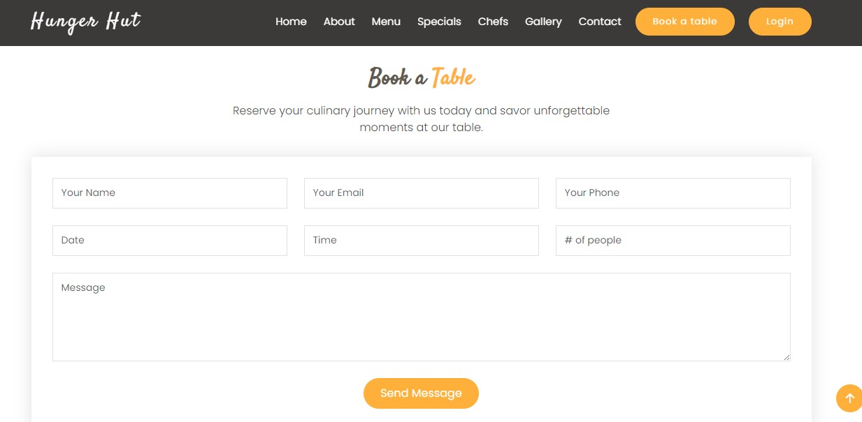

Figure 43: Book a table Section

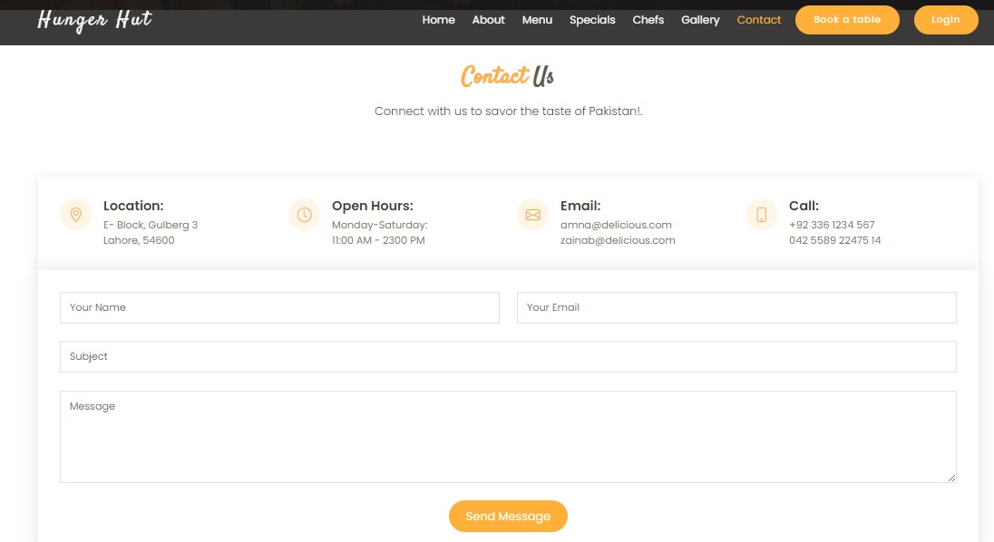

Figure 44: Contact_us Section

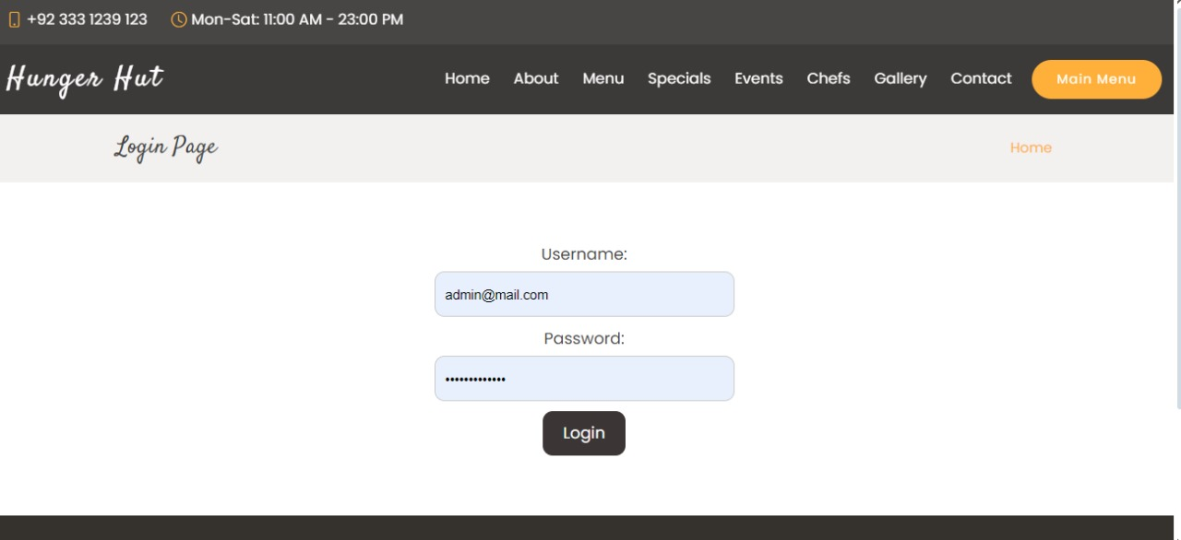

Figure 45: Login Page

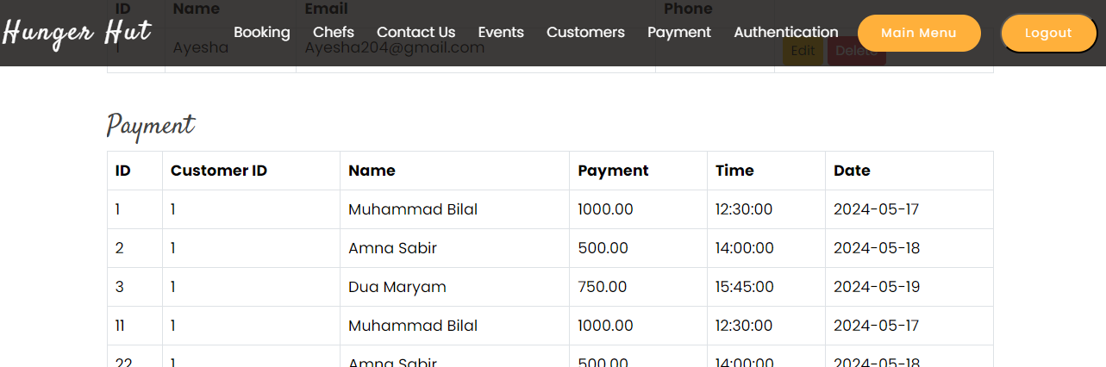Figure 46: Payment Table

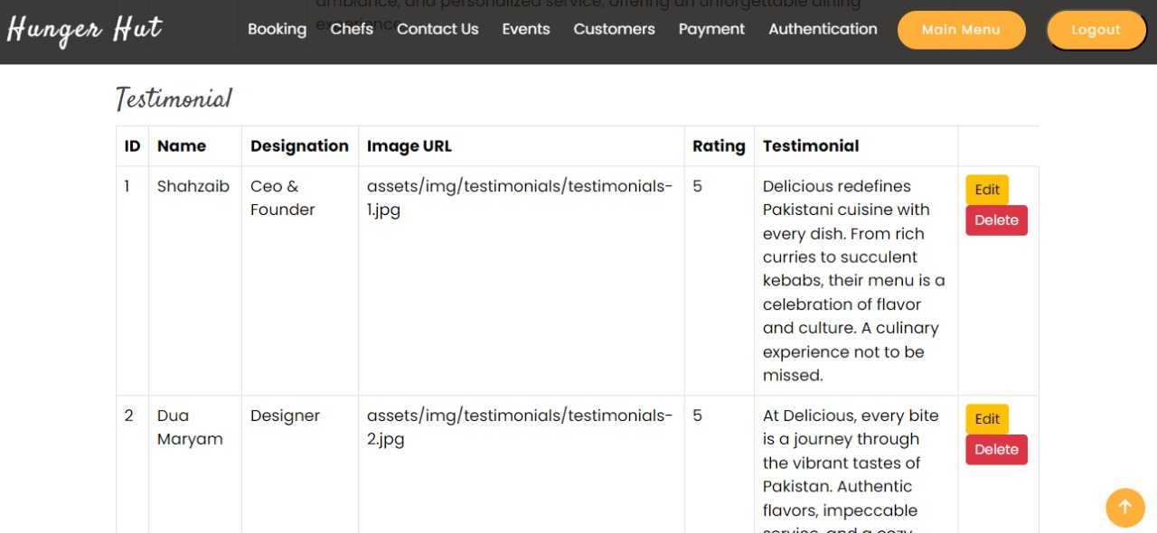

Figure 47: Testimonial Table

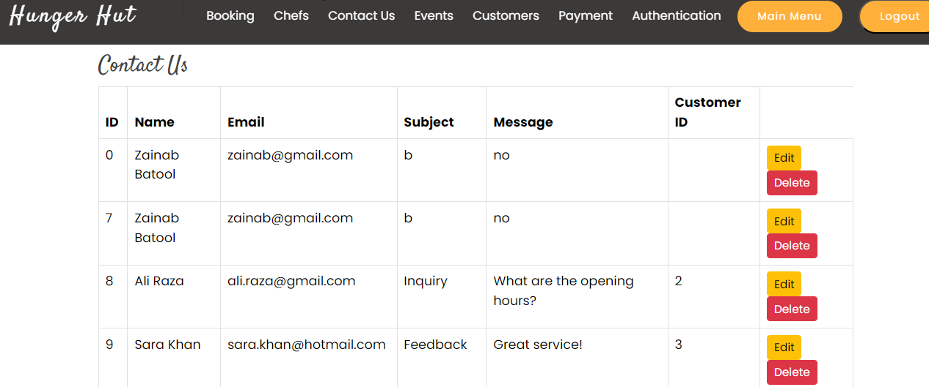

Figure 48: Contact_us

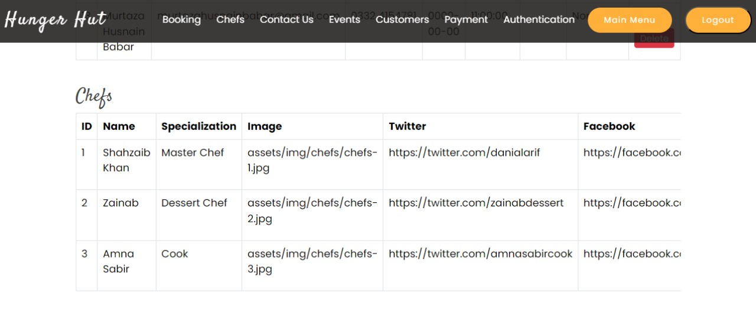Figure 49: Chefs Table

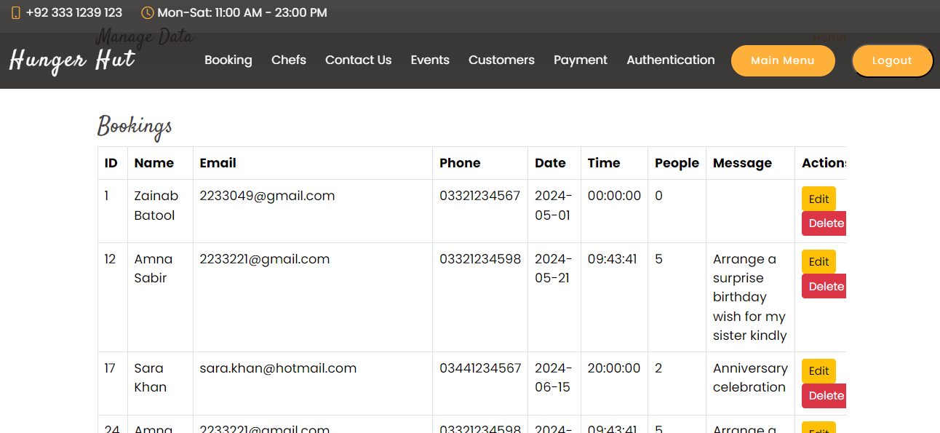

Figure 50: Booking Table

## Backend Connection with DB:

Write the backend code using PHP. This involves creating PHP scripts to handle various functionalities such as user authentication, creation, editing, deletion and booking etc.

## **Connect to the Database**:

Within your PHP scripts, establish a connection to the MySQL database using the appropriate credentials (username, password, database name and server name) and the mysql.

## **Implement CRUD Operations:**

Implement Create, Read, Update, and Delete (CRUD) operations for managing events and user data. Write PHP functions or classes to perform these operations on the database tables.

## **Security Measures:**

Implement security measures to protect against common vulnerabilities such as SQL injection, cross-site scripting (XSS), and cross-site request forgery (CSRF). Use parameterized queries, input validation, and session management techniques.

## **Testing:**

Test your backend code thoroughly to ensure that it works as expected. Test different scenarios including user registration, booking, etc.

## **Error Handling and Logging:**

Implement error handling mechanisms to gracefully handle errors and log them for debugging purposes. Use techniques like try-catch blocks and error logging functions.

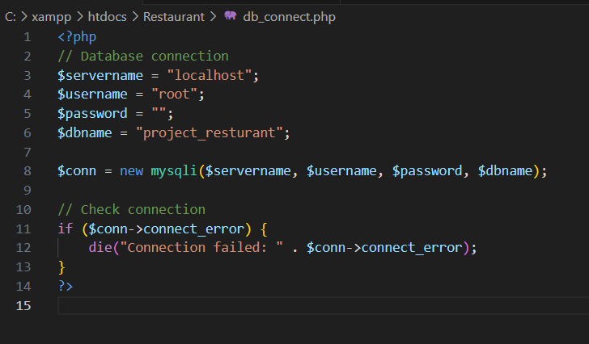

Figure 51: Database Connected

1. **Plagiarism Check Report**

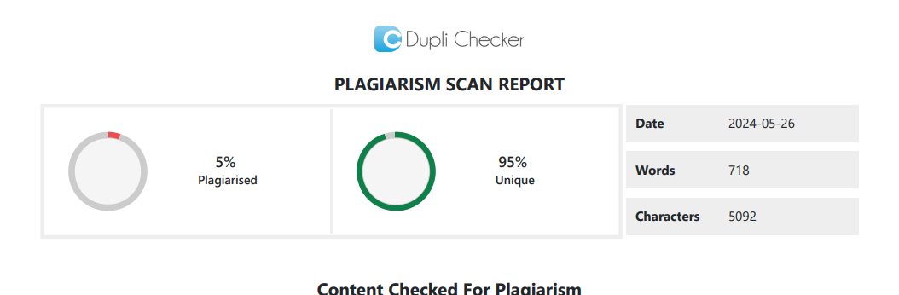

Figure 52: Plagiarism Check

# References

|  |  |
| --- | --- |
| [1] | "How to create a backend for a website using SQL server," [Online]. Available: https://www.quora.com/How-do-I-create-a-backend-for-a-website-using-SQL-server. |
| [2] | "Mediun.com," [Online]. Available: https://medium.com/@omnathdubeyofficial/diving-into-server-side-development-a-comprehensive-guide-7aff5083ce0a . |
| [3] | "Geek for Greek" [Online]. https://www.GeeksforGreek.com. |
| [4] | "W3 School" [Online]. https://www.W3school.com. |